HANOI UNIVERSITY OF SCIENCE AND TECHNOLOGY

School of Information and communications technology

Software Design Document

Version 1.0

Eco Bike Rental Software

Subject: ITSS Software Development

Group 05

Nguyen Thai An – 20176677

Bui Tu Hoang – 20176761

Vu Minh Hoang – 20176765

Nguyen Manh Khang - 20176792

*Hanoi,* *November, 2020*

Table of Contents

Table of Contents 1

1 Introduction 3

1.1 Objective 3

1.2 Scope 3

1.3 Glossary 3

1.4 References **Error! Bookmark not defined.**

2 Overall Description 5

2.1 General Overview 5

2.2 Assumptions/Constraints/Risks 5

2.2.1 Assumptions 5

2.2.2 Constraints 6

2.2.3 Risks 6

3 System Architecture and Architecture Design 7

3.1 Architectural Patterns 7

3.2 Interaction Diagrams 7

3.3 Analysis Class Diagrams 15

3.4 Unified Analysis Class Diagram 17

3.5 Security Software Architecture 17

4 Detailed Design 18

4.1 User Interface Design 18

4.1.1 Screen Configuration Standardization 18

4.1.2 Screen Transition Diagrams 20

4.1.3 Screen Specifications 20

4.2 Data Modeling 32

4.2.1 Conceptual Data Modeling 32

4.2.2 Database Design 32

4.3 Non-Database Management System Files 45

4.4 Class Design 45

4.4.1 General Class Diagram 45

4.4.2 Class Diagrams 46

4.4.3 Class Design 48

5 Design Considerations 106

5.1 Goals and Guidelines 106

5.2 Architectural Strategies 106

5.3 Coupling and Cohesion 106

5.4 Design Principles 107

5.5 Design Patterns 108

# Introduction

## Objective

The purpose of this document is to present a detailed description of the designs of the Eco Bike Rental System, created for the Eco Park township. This document is intended for the programming group in Team 5, to use the designs as guidelines to implement the project. On the other hand, this document is for reviewing by Prof. Nguyen Thi Thu Trang and her assistants, as a part of the course. The document could also be used for designers who try to upgrade or modify the design of the system

## Scope

Eco Bike Rental software’s aim, as its name, is to provide a bike renting service to customers.

In this software, user will be provided with the ability to search for docks and see their information in details. At each dock, user can have knowledge of bikes parked at the dock. Bike renting and returning are key functions of this system.

Interbank will have the possibility to execute payment transactions. Interbank will take place in the validating, adding money and deducting money processes.

This document gives a detailed description of the software architecture of the inventory system. It specifies the structure and design of some of the modules discussed in the SRS. It also provides sequential and activity diagrams for some use case. The class diagrams show how the programming team would implement the specific module.

## Glossary

|  |  |
| --- | --- |
| Word | Meaning |
| deposit | to pay someone an amount of money when you make an agreement with that person to pay for or buy something, that either will be returned to you later, if the agreed arrangement is kept, or that forms part of the total payment |
| deduct | to take away an amount or part from a total |
| transaction | an occasion when someone buys or sells something, or when money is exchanged or the activity of buying or selling something |

## References

# Overall Description

## General Overview

The EBR system is a simulator for a bike rental service. This is a desktop software run on Java Runtime Environment. This software is designed using the MVC architectural design model.

The general use case diagram is as following:

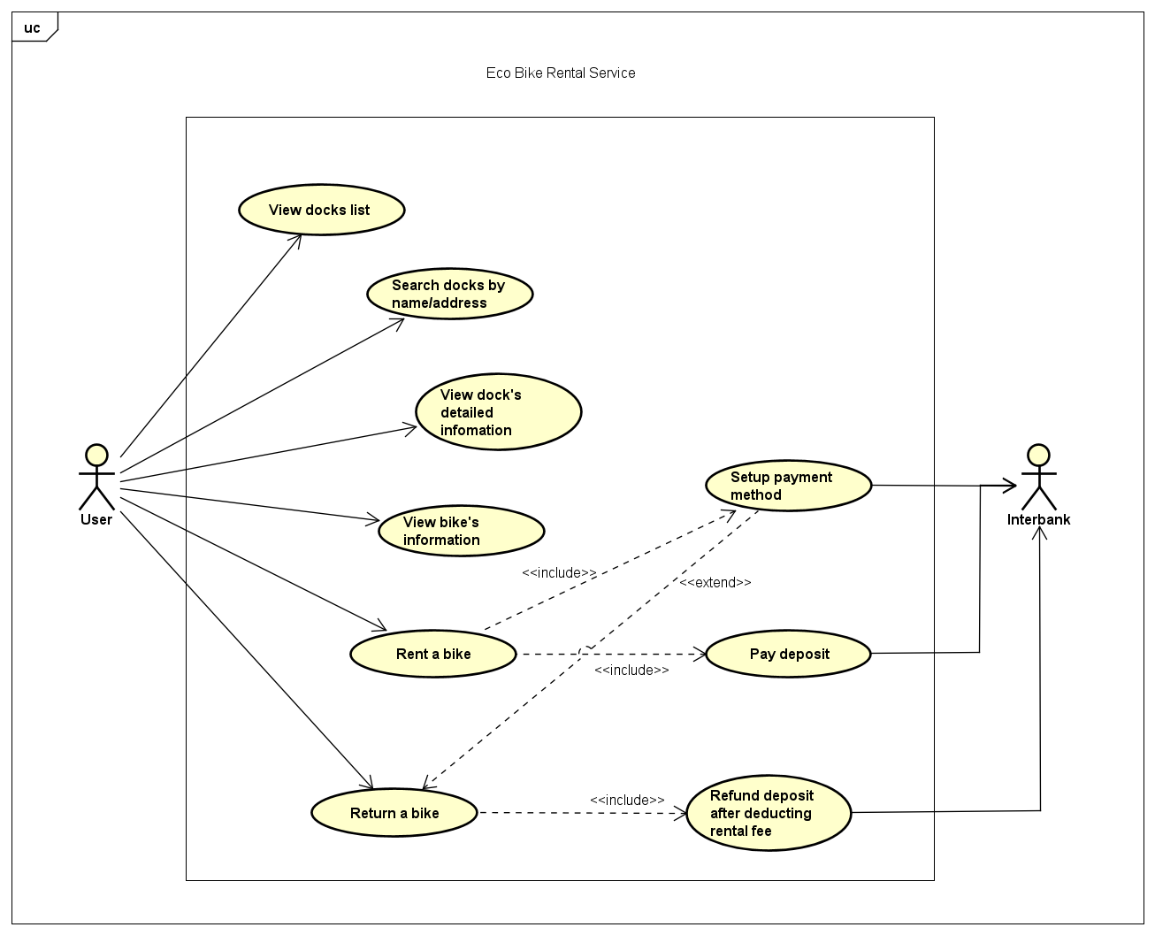

## Assumptions/Constraints/Risks

### Assumptions

*The design described in this document is based on simulation requirements instead of reality requirements. Therefore, functions related to authentication and personal customer information are neglected.*

*This software is designed to run on any operating system with Java Runtime Environment.*

### Constraints

The system is built accessible only through personal computer. The system is implemented using Java and uses JavaFX for making user interfaces.

For storing data, PostgreSQL will be used with the help of JDBC

### Risks

# System Architecture and Architecture Design

## Architectural Patterns

Model-View-Controller (MVC) is the chosen design pattern. The concept of MVC which used in this project can be described by the image below

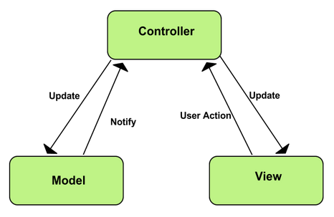

MVC has its own advantages:

Simultaneous development - Multiple developers can work simultaneously on the model, controller and views.

[High cohesion](https://en.wikipedia.org/wiki/Cohesion_(computer_science)) - MVC enables logical grouping of related actions on a controller together.

[Low coupling](https://en.wikipedia.org/wiki/Loose_coupling) - The very nature of the MVC framework is such that there is low coupling among models, views or controllers.

Ease of modification - Because of the separation, future development or modification is easier, and also the scalability.

## Interaction Diagrams

### Browse Docks and Bikes

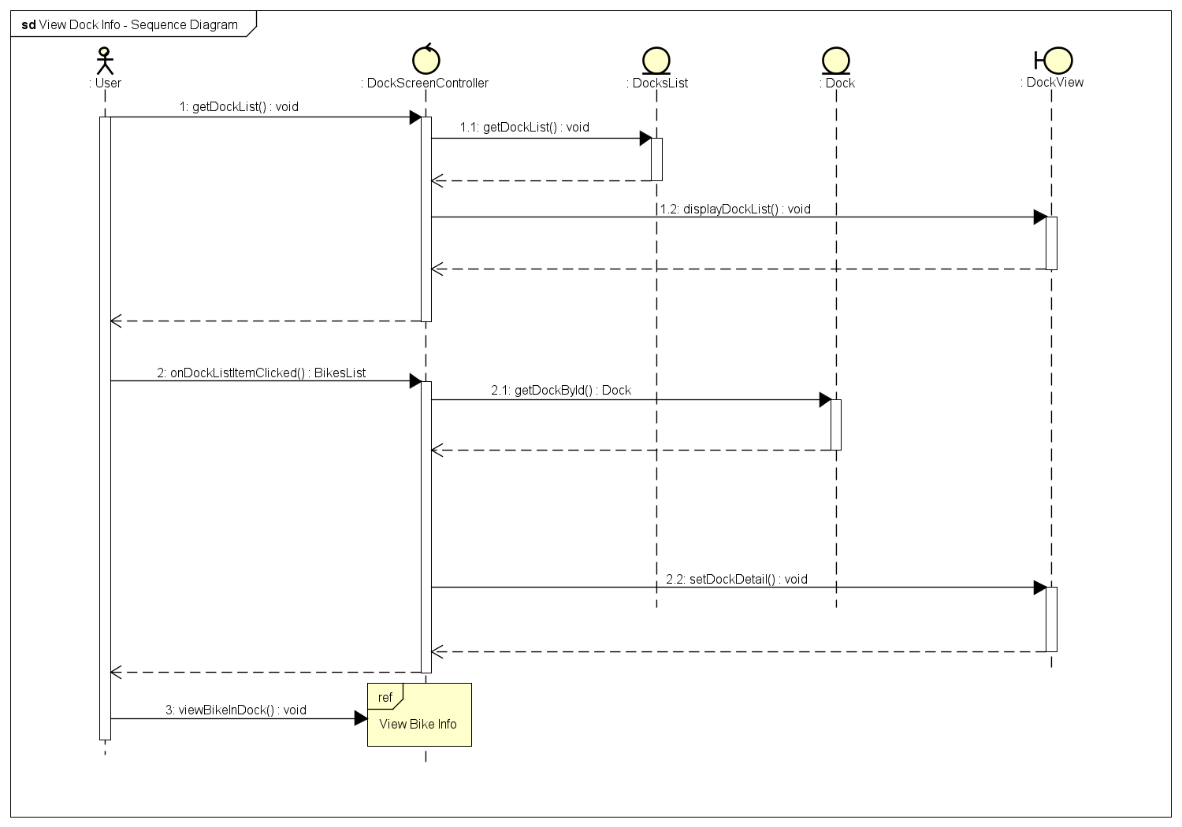

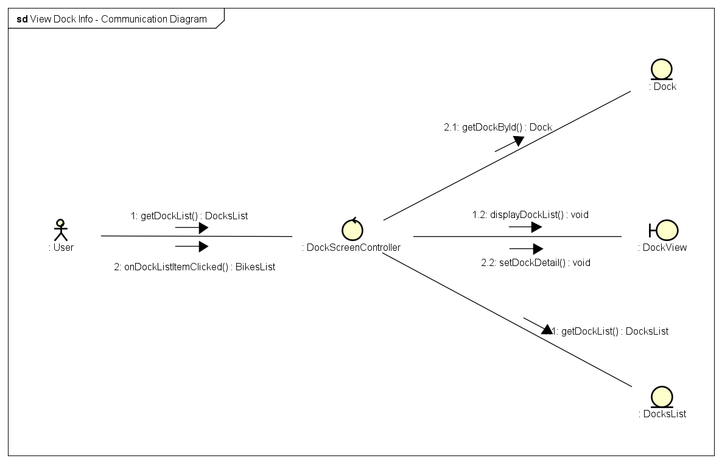

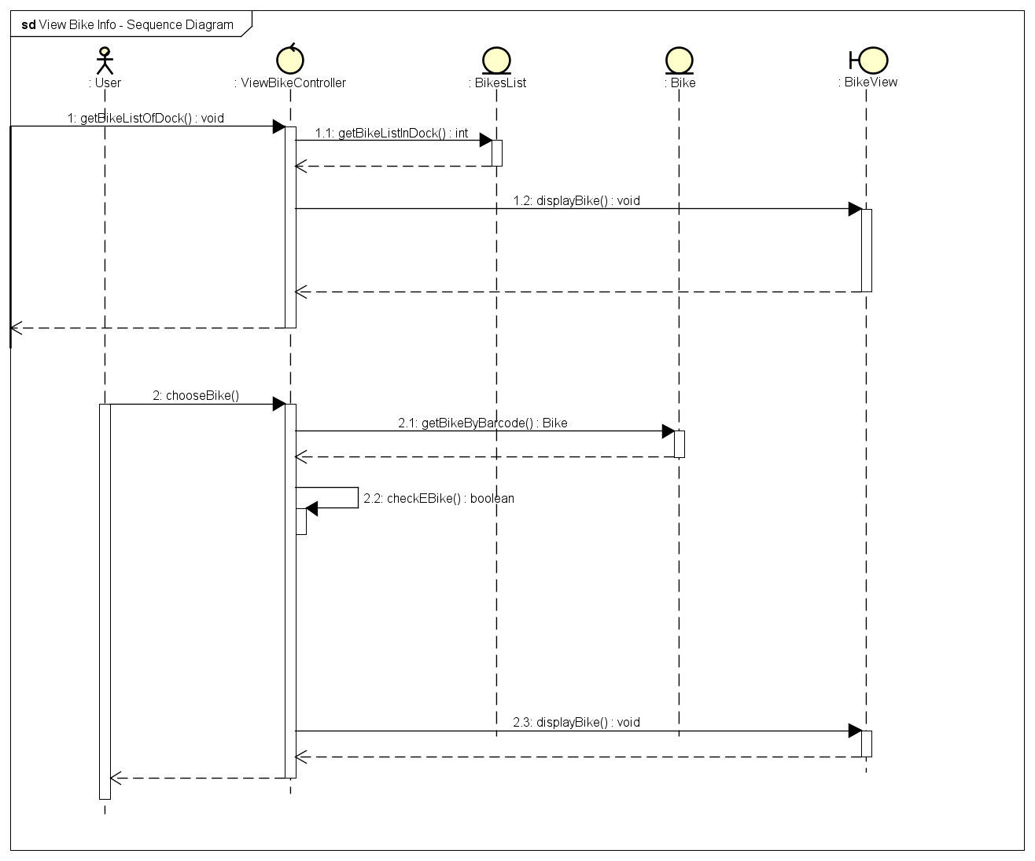

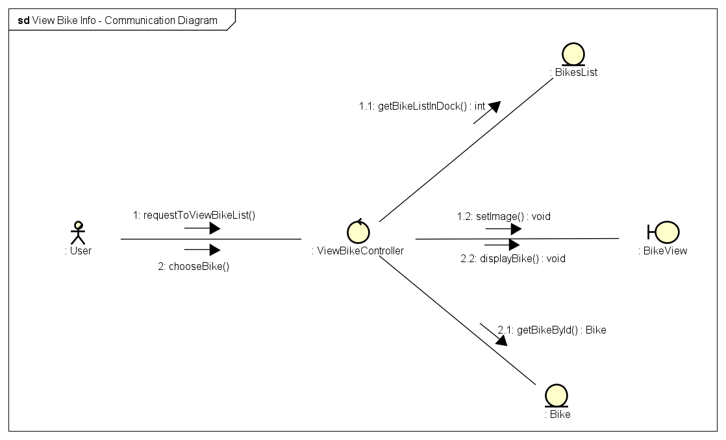

### Setup Payment Method

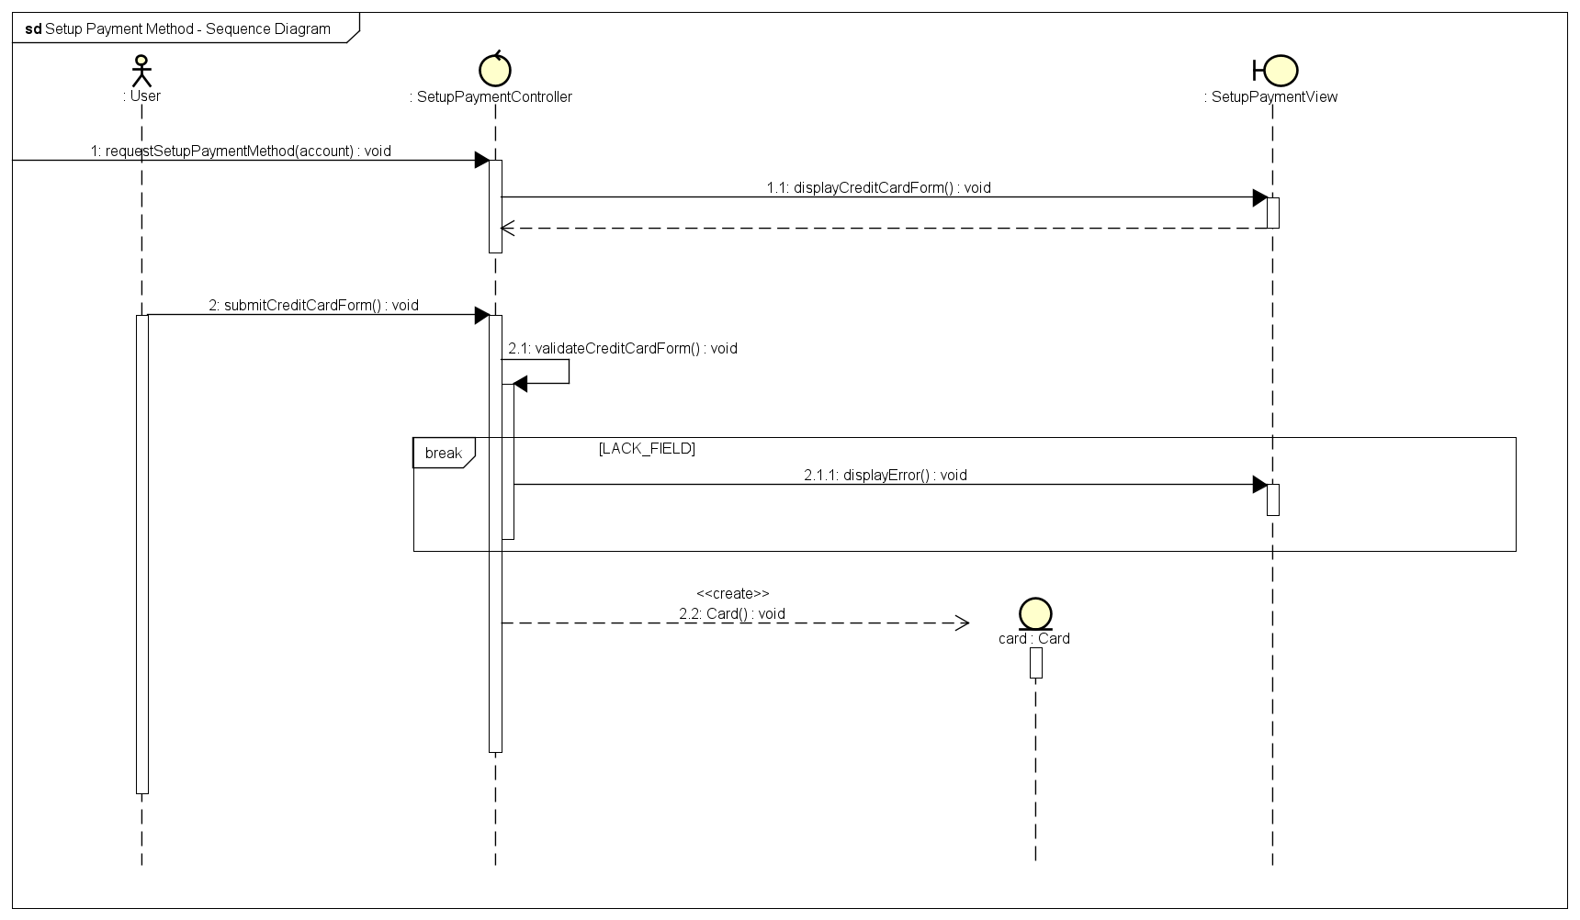

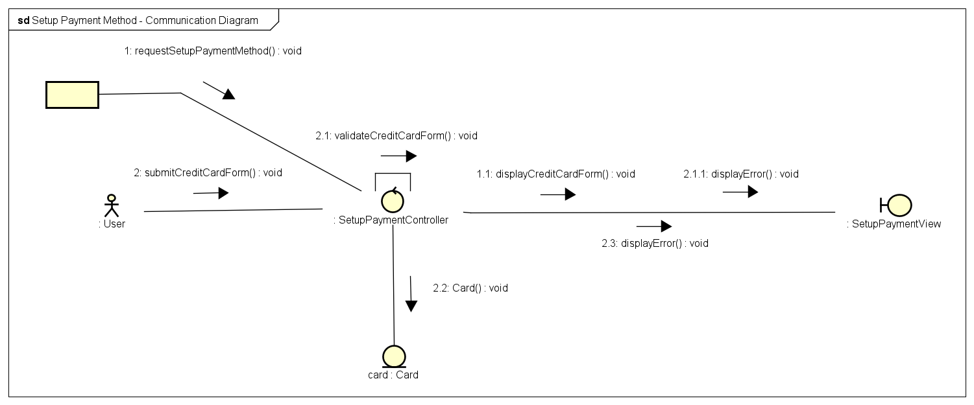

### Rent Bike

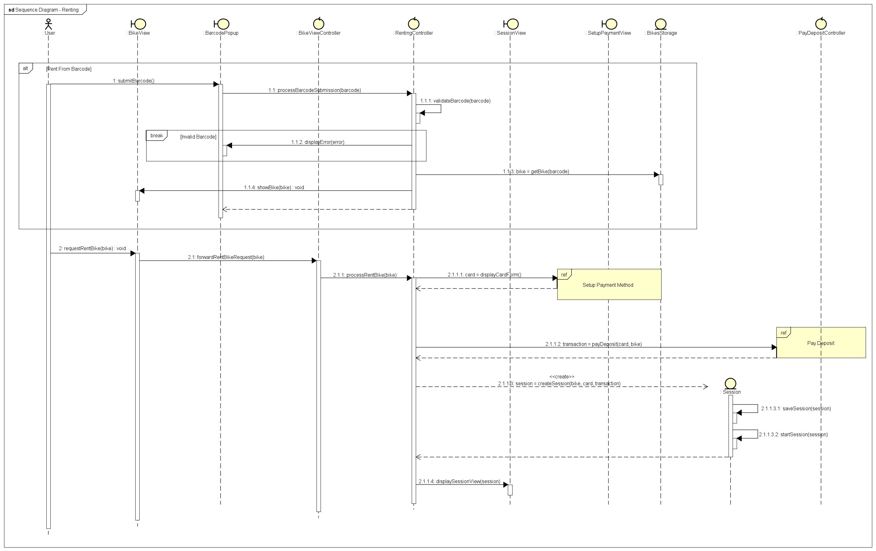

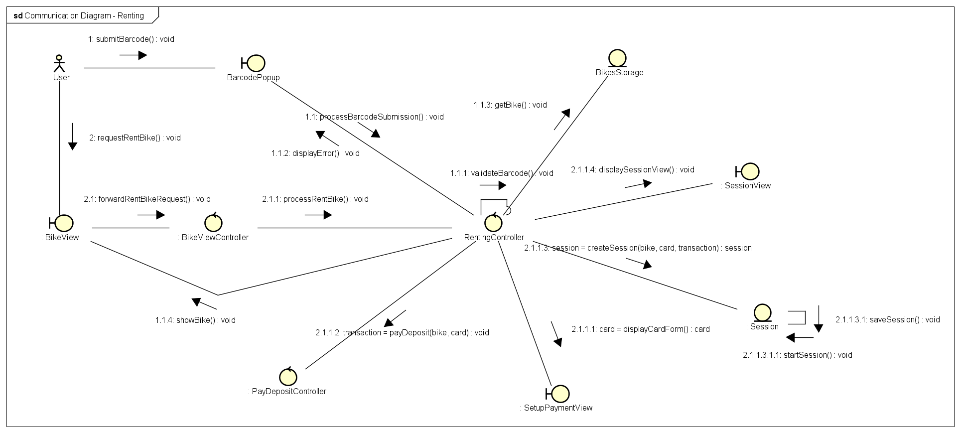

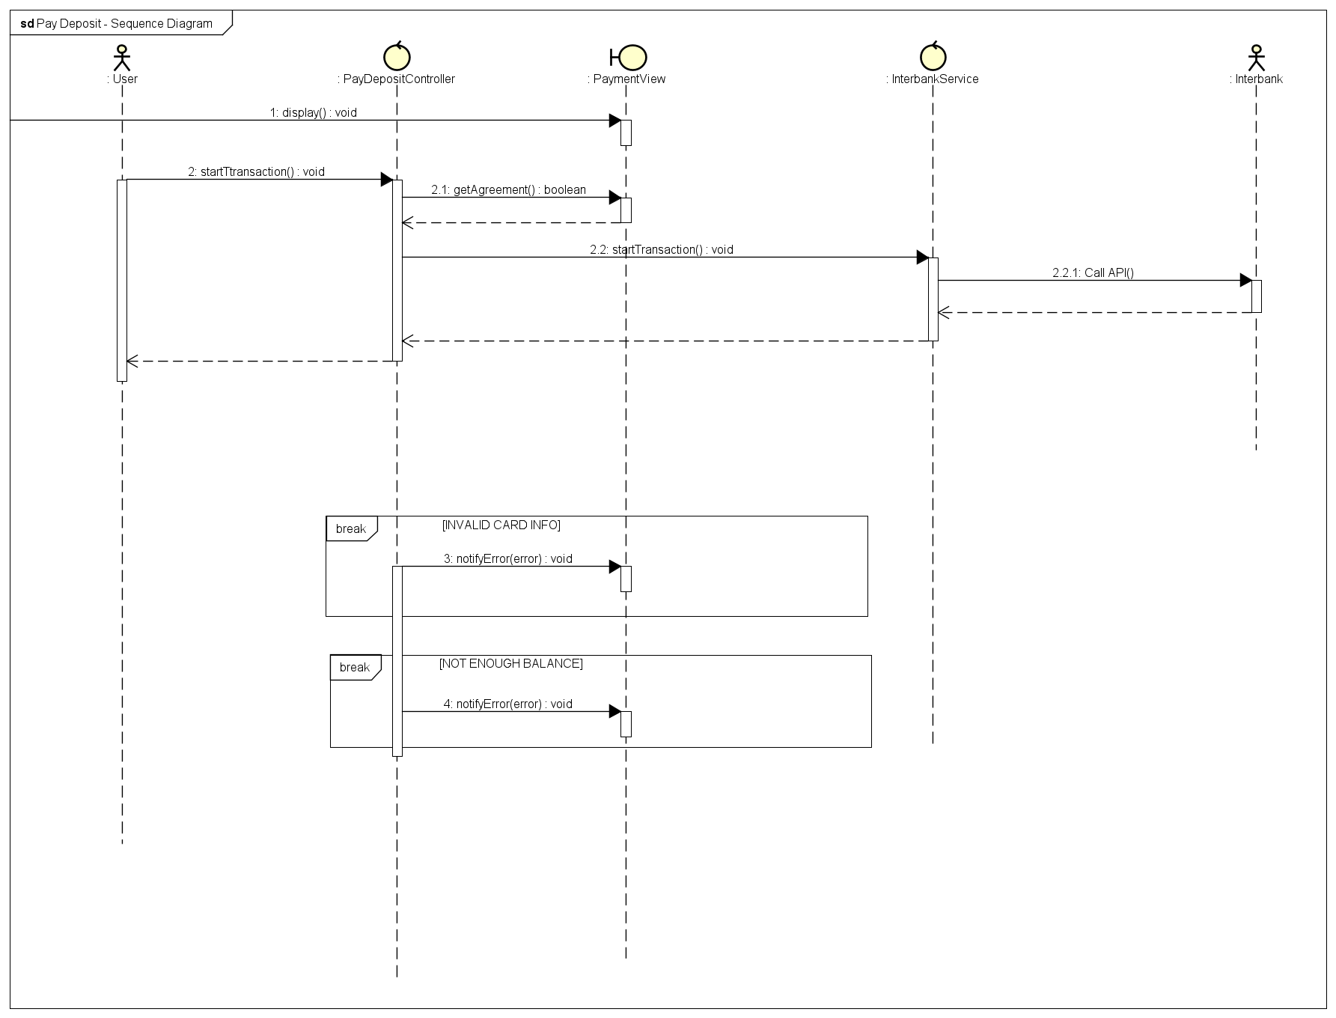

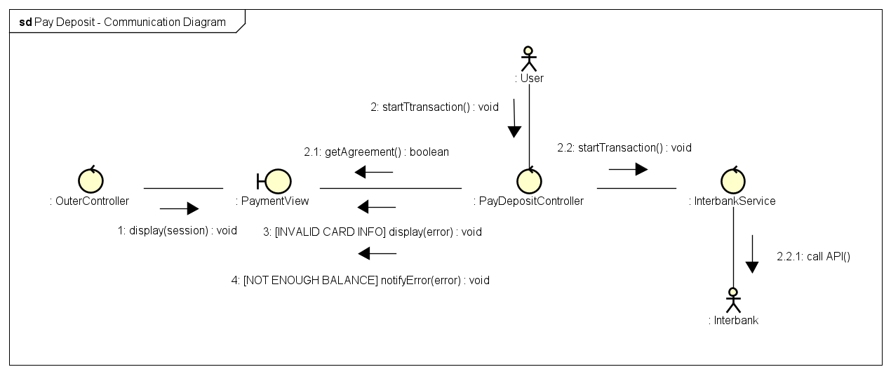

### Return Bike

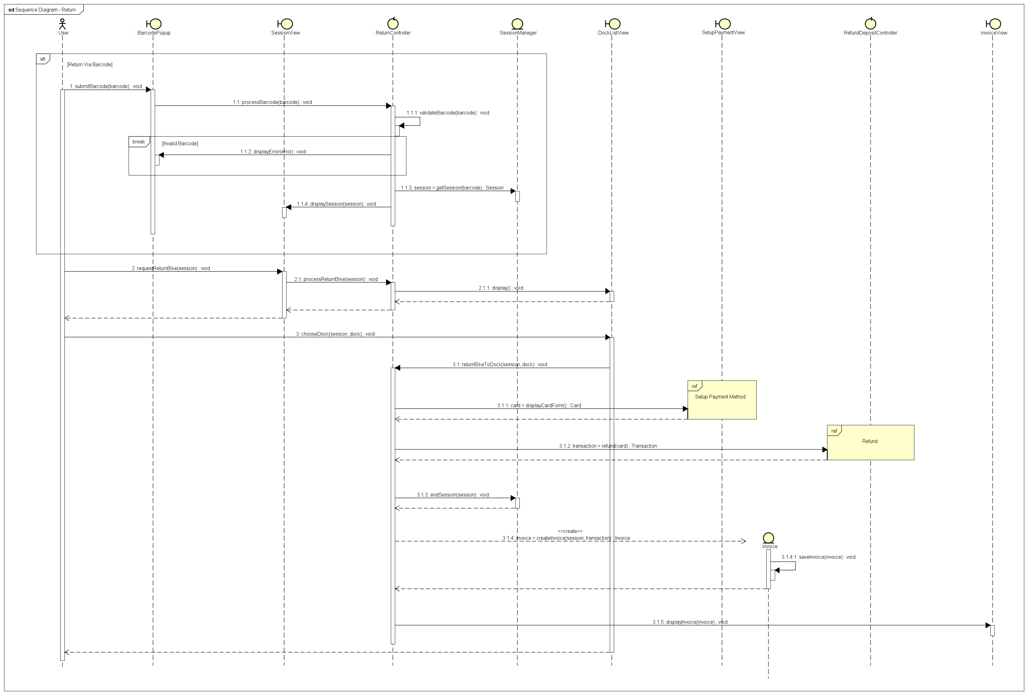

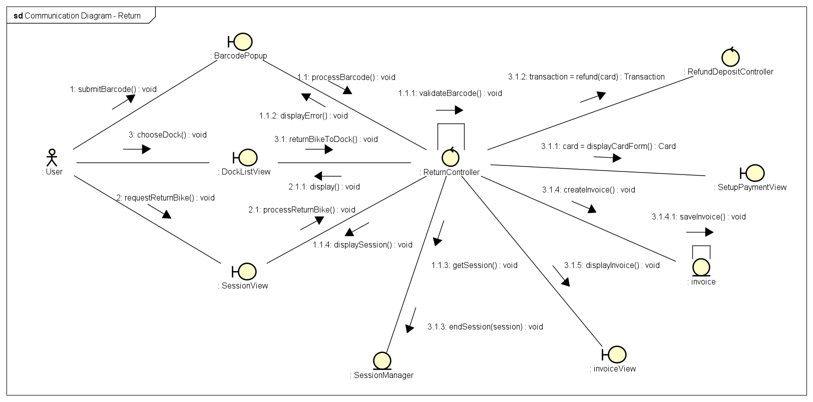

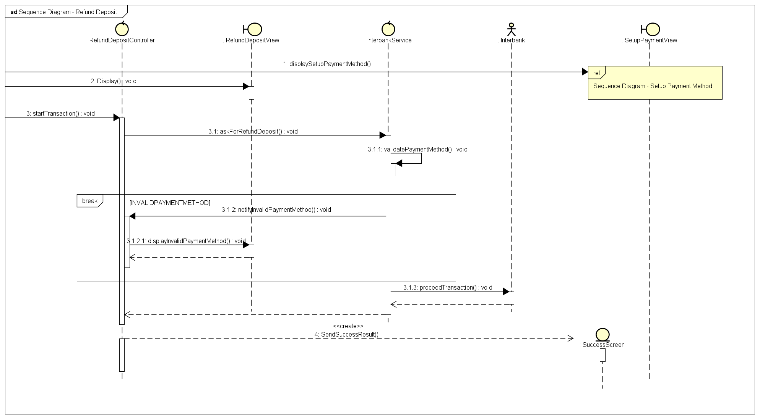

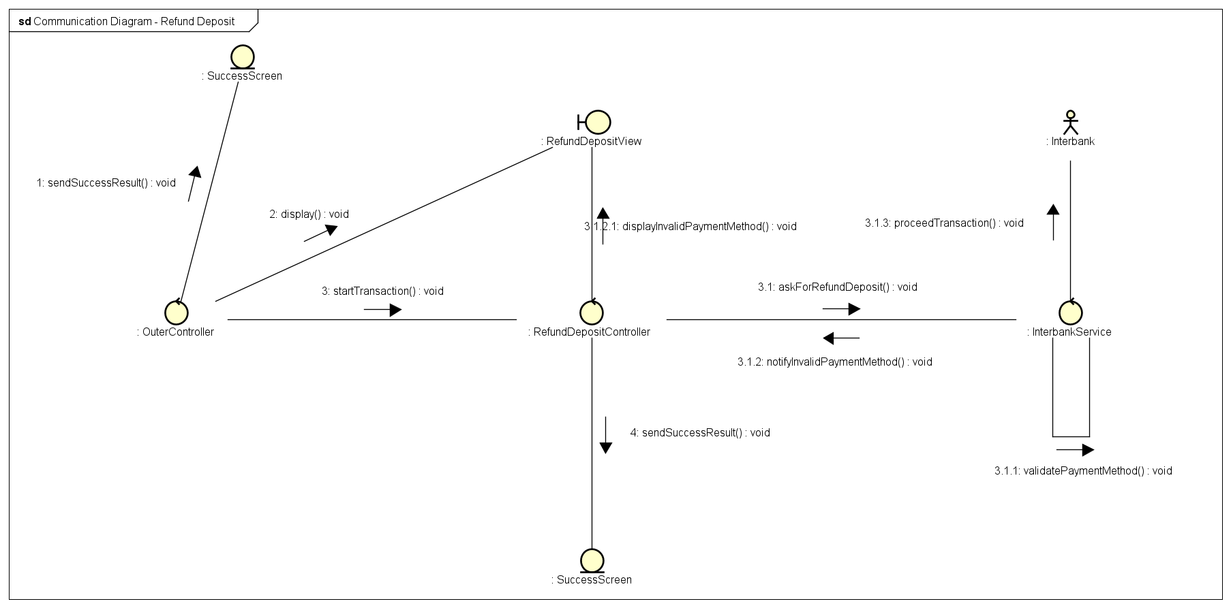

## Analysis Class Diagrams

### Docks and Bikes

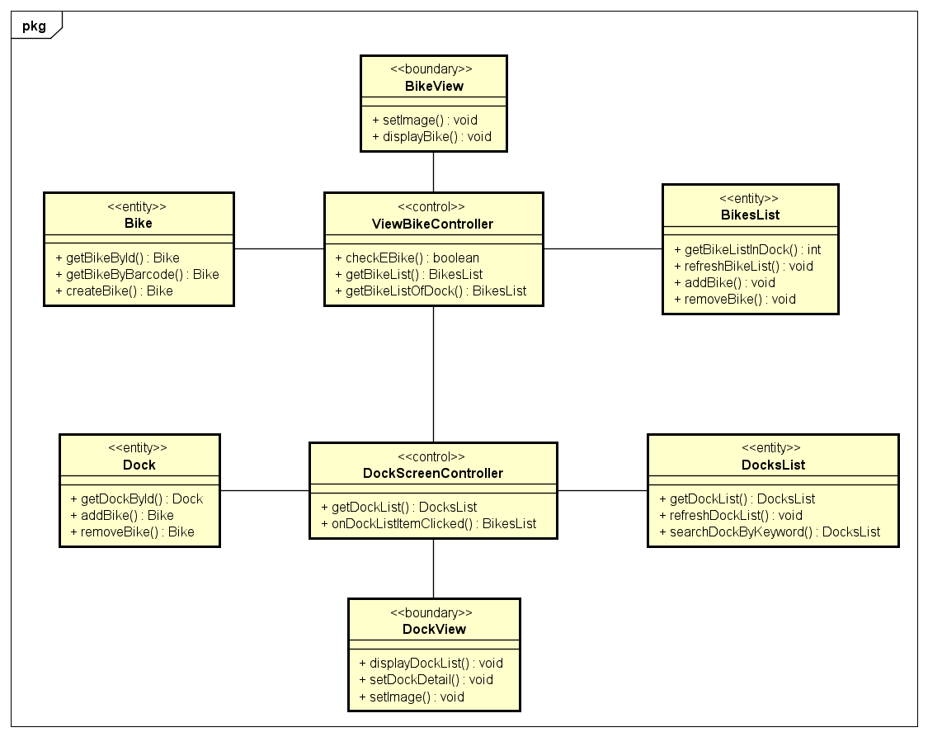

### Setup Payment

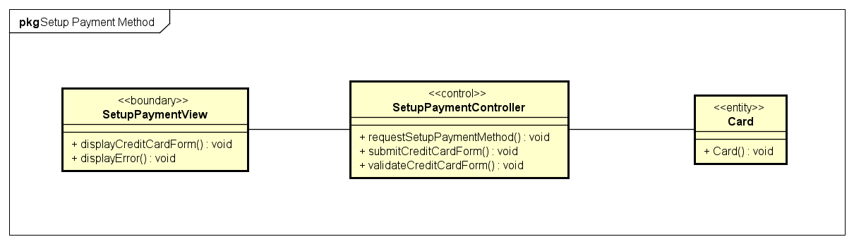

### Rent Bike

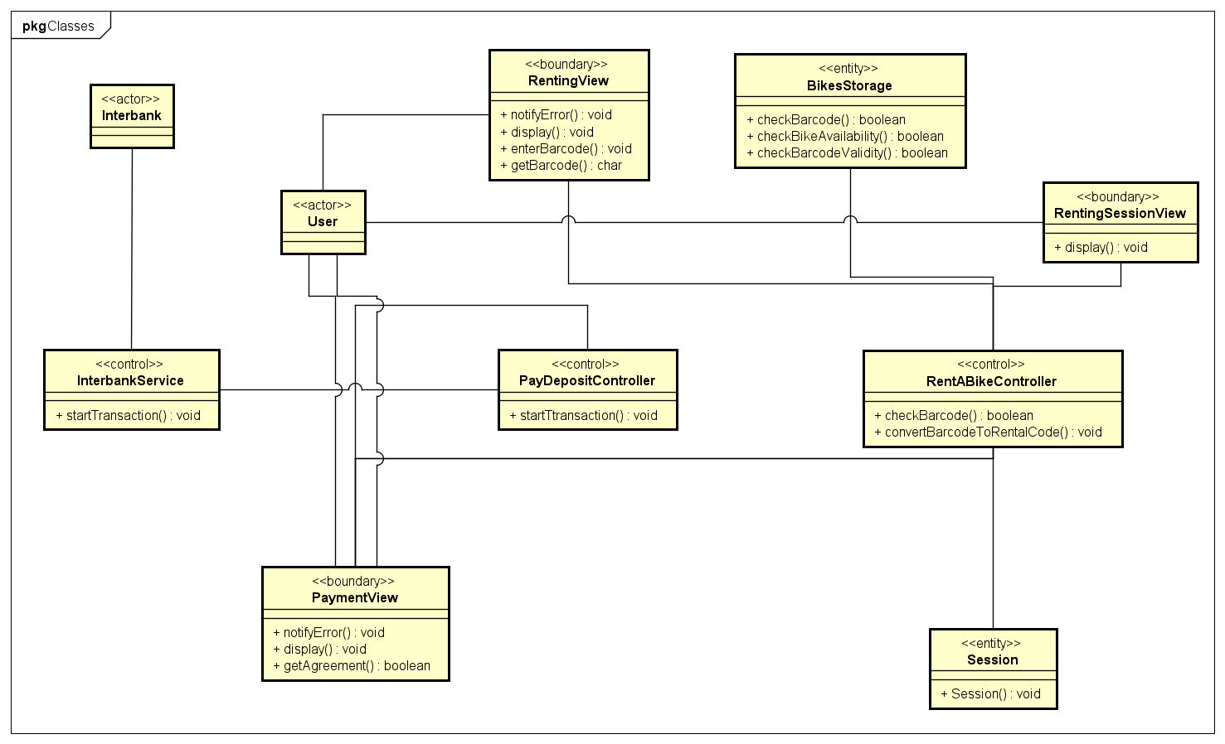

### Return Bike

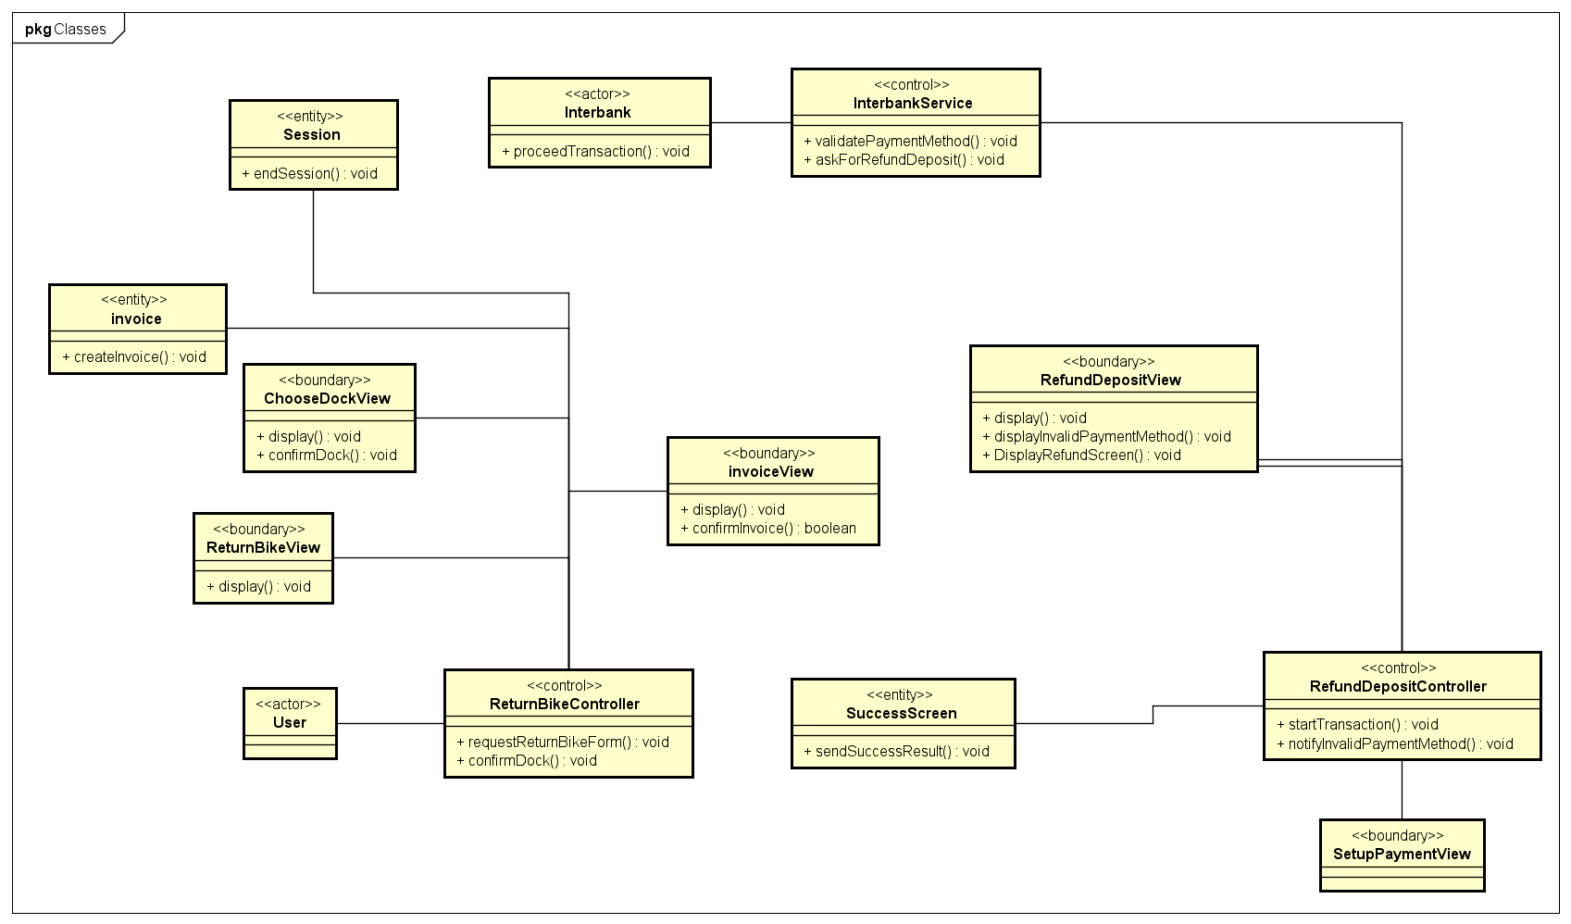

## Unified Analysis Class Diagram

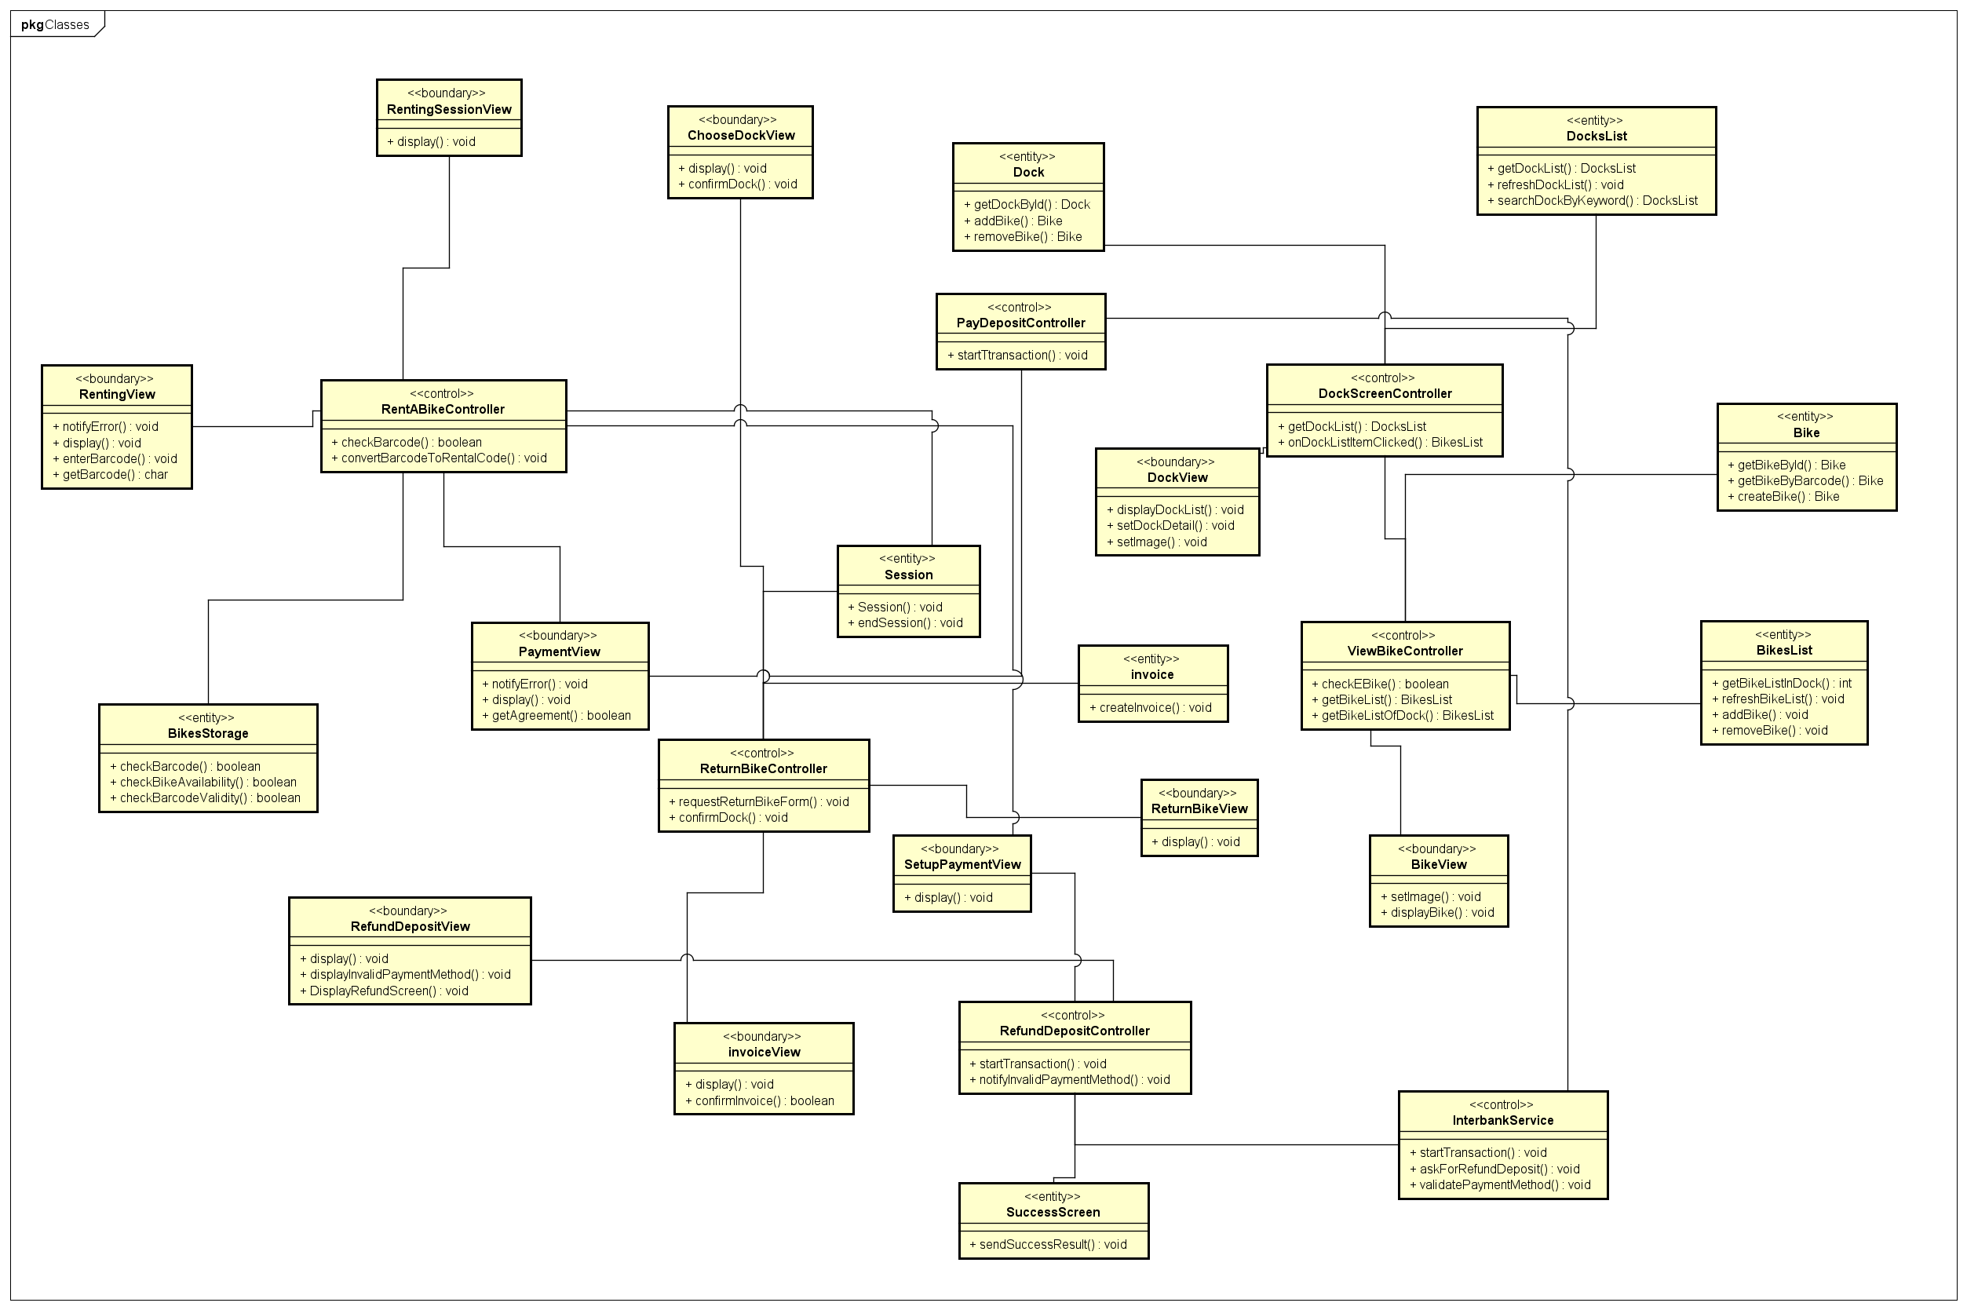

## Security Software Architecture

# Detailed Design

## User Interface Design

### Screen Configuration Standardization

***Display***

*Number of colors supported:* 16,777,216 colors

*Resolution:* 1366 × 768 𝑝𝑖𝑥𝑒𝑙𝑠

***Screen***

*Location of standard buttons:* At the bottom (vertically) and in the middle

(horizontally) of the frame.

* Affirmative button to the right, background-color: #8C36C0, text-color: #FFFFFF
* Negative button to the left, background-color: #FFFFFF, text-color: #8C36C0

*Location of the messages:* Starting from the top vertically and in the middle

horizontally of the frame down to the bottom.

*Display of the screen title:* The title is located at the center-top of the screen and also on the top-left of the window bar.

*Consistency in expression of alphanumeric numbers:* no separator for

thousand while strings only consist of characters, digits, commas, dots, spaces,

underscores, and hyphen symbol.

***Control***

*Size of the text:*

* Title and header text: font: Roboto, style: bold, size: 48px, color: #8C36C0

(medium-dark purple)

* Text in button: font: Roboto, style: black, size: 24px, color: #FFFFFF
* Other text: font: Roboto, style: regular, size: 14px, color: #000000

Input check process: Should check if it is empty or not. Next, check if the input is in the correct format or not

*Sequence of moving the focus:* There will be some popup screen. The popup screen will overlay the current parent screen. Cannot interact with parent screen while the popup screen overlaying. Click outside of the popup screen will close it, return active screen to the parent screen.

After the opening screen, the app will start with splash screen, and then the first screen (homescreen) will appear.

*Sequences of the system screens:*

1. Splash screen (first screen)
2. Home screen – show list of docks
3. Barcode Popup – for inputting the barcode (rent/return bike)
4. Dock View Screen – view all available bikes and dock’s info
5. Bike View Screen – detailed bike’s info
6. Payment Screen – fill in payment method (credit card)
7. Transaction Result Popup – show the result of transaction
8. Renting Session – all session’s info (start time, current rental fee, bike’s info…)
9. Invoice screen – view order details
10. Dock Selection Screen – for choosing dock when returning

***Direct input from the keyboard***

There will be no shortcuts. There are back buttons to move back to the previous screen located at the top-right corner of each screen. All input fields take input directly from keyboard.

***Error***

A message will be given to notify the users what is the problem.

### Screen Transition Diagrams

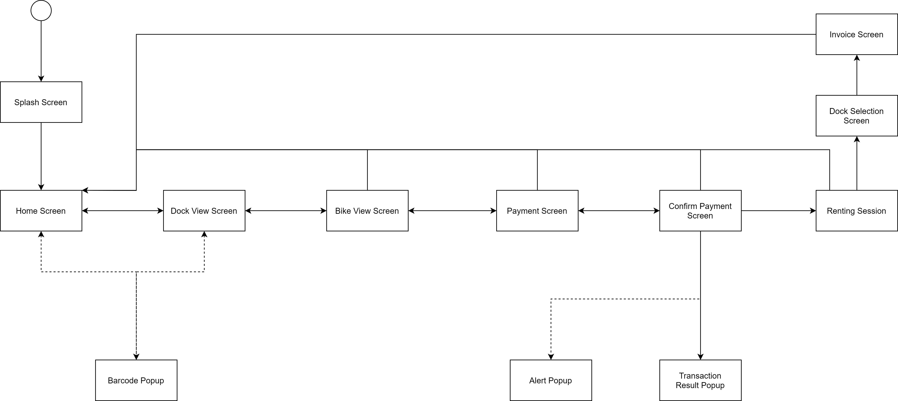

### Screen Specifications

#### Home Screen

|  |  |  |  |  |  |
| --- | --- | --- | --- | --- | --- |
| EBR Software | | Date of creation | Approved by | Reviewed by | Person in charge |
| Screen specification | Home Screen | 6/11/2020 |  |  | Nguyễn Thái An |
|  | | Control | Operation | Function | |
| Enter Barcode Button | Click | Display Barcode Popup Screen | |
| Back button | Click | Back to Splash Screen | |
| Area for entering search | Initial | Display “search” faded word | |

Defining the field attributes

|  |  |  |  |  |
| --- | --- | --- | --- | --- |
| Screen name | Home Screen | | | |
| Item name | Number of digits (bytes) | Type | Field attribute | Remarks |
| Search field | 50 | String | Black | Left justified |
| Dock’s name | 30 | String | White | Left justified |
| Dock’s address | 50 | String | White | Left justified |
| Bike Number | 4 | Int | White | Left justified |

#### Payment Screen

|  |  |  |  |  |  |
| --- | --- | --- | --- | --- | --- |
| EBR Software | | Date of creation | Approved by | Reviewed by | Person in charge |
| Screen specification | Payment Screen | 6/11/2020 |  |  | Nguyễn Thái An |
|  | | Control | Operation | Function | |
| Place holder text in input fields | Initial | Display what kind of information need for the field | |
| Back button | Click | Navigate to the previous screen. | |
| Confirm button | Click | Process payment, show Renting Session Screen | |
| Cancel button | Click | Navigate back to Home Screen | |

Defining the field attributes

|  |  |  |  |  |
| --- | --- | --- | --- | --- |
| Screen name | Payment Screen | | | |
| Item name | Number of digits (bytes) | Type | Field attribute | Remarks |
| Card Owner | 30 | String | Black | Left justified |
| Card Number | 16 | Numeral | Black | Left justified |
| EXP date | 5 | String | Black | Left justified, MM/YY |
| Security Code | 3 | Numeral | Black | Left justified |

#### Dock View Screen

|  |  |  |  |  |  |
| --- | --- | --- | --- | --- | --- |
| EBR Software | | Date of creation | Approved by | Reviewed by | Person in charge |
| Screen specification | Dock View Screen | 7/11/2020 |  |  | Bùi Tú Hoàng |
|  | | Control | Operation | Function | |
| Enter Barcode Button | Click | Display Barcode Popup Screen | |
| Back Button | Click | Back to Home Screen | |
| Rent Bike Button | Click | Display Bike View Screen | |
| EBR Home Screen Button | Click | Display Home Screen | |
| Area for Displaying Number of Spots and Bikes | Initial | Displaying Number of Spots and Bikes | |
| Area for Displaying Bike in the Dock | Initial | Displaying Bike in the Dock | |

Defining the field attributes

|  |  |  |  |  |
| --- | --- | --- | --- | --- |
| Screen name | Dock View Screen | | | |
| Item name | Number of digits (bytes) | Type | Field attribute | Remarks |
| Number of Spot | 3 | Numeral | Black | Right justified |
| Number of Standard Bike | 3 | Numeral | Black | Right justified |
| Number of Twin Bike | 3 | Numeral | Black | Right justified |
| Number of E-Bike | 3 | Numeral | Black | Right justified |
| Bike Barcode | 10 | String | Black | Center justified |
| Battery Left | 4 | String | Green | Center justified |
| Bike Type | 6 | Numeral | Black | Center justified |

#### Bike View Screen

|  |  |  |  |  |  |
| --- | --- | --- | --- | --- | --- |
| EBR Software | | Date of creation | Approved by | Reviewed by | Person in charge |
| Screen specification | Bike View Screen | 7/11/2020 |  |  | Bùi Tú Hoàng |
|  | | Control | Operation | Function | |
| Back Button | Click | Back to the Dock View screen. | |
| Rent Now Button | Click | Display Payment Screen | |
| EBR Home Screen Button | Click | Display Home Screen | |
| Area for displaying the Bike Information | Initial | Displaying the Bike Information and Deposit | |
| Area for displaying Renting Charge | Initial | Displaying Renting Charge | |

Defining the field attributes

|  |  |  |  |  |
| --- | --- | --- | --- | --- |
| Screen name | Bike View Screen | | | |
| Item name | Number of digits (bytes) | Type | Field attribute | Remarks |
| Bike Code | 8 | String | Black | Left justified |
| Location | 30 | String | Black | Left justified |
| Battery | 4 | String | Black | Left justified |
| Usage | 25 | String | Black | Right justified |
| Deposit | 15 | String | Purple | Right justified |
| Charge | 15 | String | Green | Right justified |
| Number of Saddle | 1 | Numeral | Black | Left justified |
| Number of Rear Seat | 1 | Numeral | Black | Left justified |
| Number of Pedal | 1 | Numeral | Black | Left justified |

#### Renting Session Screen

|  |  |  |  |  |  |
| --- | --- | --- | --- | --- | --- |
| EBR Software | | Date of creation | Approved by | Reviewed by | Person in charge |
| Screen specification | Renting Session Screen | 7/11/2020 |  |  | Nguyễn Mạnh Khang |
|  | | Control | Operation | Function | |
| Enter Barcode Button | Click | Display Barcode Popup Screen | |
| Back Button | Click | Navigate to the previous screen. | |
| Return Bike button | Click | Display Invoice Screen | |
| EBR Home Screen Button | Click | Display Home Screen | |
| Play/Pause Button | Click | Pause session | |
| Area for displaying the Session Information | Initial | Displaying the Session Information and Deposit | |
| Area for displaying Renting Fees | Initial | Displaying Renting Fees | |
| Close button | Click | Display Home Screen | |

Defining the field attributes

|  |  |  |  |  |
| --- | --- | --- | --- | --- |
| Screen name | Bike View Screen | | | |
| Item name | Number of digits (bytes) | Type | Field attribute | Remarks |
| Bike Code | 8 | String | Black | Left justified |
| Start time | 30 | String | Black | Left justified |
| Battery | 4 | String | Black | Left justified |
| Usage | 25 | String | Black | Left justified |
| Session length | 8 | String | Black | Left justified |
| Charge | 15 | String | Green | Right justified |
| Renting fees | 15 | String | Purple | Right justified |

#### Invoice Screen

|  |  |  |  |  |  |
| --- | --- | --- | --- | --- | --- |
| EBR Software | | Date of creation | Approved by | Reviewed by | Person in charge |
| Screen specification | Invoice Screen | 7/11/2020 |  |  | Nguyễn Mạnh Khang |
|  | | Control | Operation | Function | |
| Return Home Button | Click | Display Payment Screen | |
| Area for displaying the Session Information | Initial | Displaying the Session Information and Fees | |
| Area for displaying Returned | Initial | Displaying Returned money | |

Defining the field attributes

|  |  |  |  |  |
| --- | --- | --- | --- | --- |
| Screen name | Invoice Screen | | | |
| Item name | Number of digits (bytes) | Type | Field attribute | Remarks |
| Card number | 20 | String | Black | Left justified |
| Card Owner | 20 | String | Black | Left justified |
| Exp Date | 5 | Numeric | Black | Left justified |
| Security Code | 4 | Numeric | Black | Left justified |
| Start time | 30 | String | Black | Left justified |
| End time | 30 | String | Black | Left justified |
| Total fees | 30 | String | Green | Left justified |
| Deposit | 30 | String | Green | Left justified |
| Returned | 30 | String | Green | Right justified |

#### Splash Screen

|  |  |  |  |  |  |
| --- | --- | --- | --- | --- | --- |
| EBR Software | | Date of creation | Approved by | Reviewed by | Person in charge |
| Screen specification | Splash Screen | 7/11/2020 |  |  | Vũ Minh Hoàng |
|  | | Control | Operation | Function | |
| Home Screen Button | Click | Display Home Screen | |

Defining the field attributes

|  |  |  |  |  |
| --- | --- | --- | --- | --- |
| Screen name | Dock View Screen | | | |
| Item name | Number of digits (bytes) | Type | Field attribute | Remarks |

#### Barcode Popup Screen

|  |  |  |  |  |  |
| --- | --- | --- | --- | --- | --- |
| EBR Software | | Date of creation | Approved by | Reviewed by | Person in charge |
| Screen specification | Barcode Popup | 7/11/2020 |  |  | Vũ Minh Hoàng |
|  | | Control | Operation | Function | |
| Area for Entering Barcode | Initial | Display a text holder for entering barcode for renting bike | |
| Confirm Button | Click | Navigate to the previous screen. | |

Defining the field attributes

|  |  |  |  |  |
| --- | --- | --- | --- | --- |
| Screen name | Bike View Screen | | | |
| Item name | Number of digits (bytes) | Type | Field attribute | Remarks |
| Barcode | 8 | String | Black | Left justified |

#### Payment Confirmation Screen

|  |  |  |  |  |  |
| --- | --- | --- | --- | --- | --- |
| EBR Software | | Date of creation | Approved by | Reviewed by | Person in charge |
| Screen specification | Payment Confirmation | 7/11/2020 |  |  | Vũ Minh Hoàng |
|  | | Control | Operation | Function | |
| Enter Barcode Button | Click | Display Barcode Popup Screen | |
| Back Button | Click | Back to the Payment Screen | |
| Return Dock Button | Click | Return to the Dock Screen | |
| EBR Home Screen Button | Click | Display Home Screen | |
| Area for display Payment Information | Initial | Display the Bike Code, Card Number and Total money | |
| Confirm Payment Button | Click | Display Renting Session | |

Defining the field attributes

|  |  |  |  |  |
| --- | --- | --- | --- | --- |
| Screen name | Bike View Screen | | | |
| Item name | Number of digits (bytes) | Type | Field attribute | Remarks |
| Bike Code | 8 | String | Black | Left justified |
| Bike Type | 30 | String | Black | Left justified |
| Card number | 20 | String | Black | Left justified |
| Card Owner | 20 | String | Black | Left justified |
| Exp Date | 5 | Numeric | Black | Left justified |
| Security Code | 4 | Numeric | Black | Left justified |
| Deposit | 15 | String | Green | Left justified |
| Charge | 15 | String | Green | Left justified |
| Amount | 15 | String | Green | Right justified |

#### Transaction Result Popup Screen

|  |  |  |  |  |  |
| --- | --- | --- | --- | --- | --- |
| EBR Software | | Date of creation | Approved by | Reviewed by | Person in charge |
| Screen specification | Transaction Result | 26/12/2020 |  |  | Vũ Minh Hoàng |
|  | | Control | Operation | Function | |
| Close Button | Click | Close Popup | |
| Area for display transaction Information | Initial | Display transaction result and transaction info | |

Defining the field attributes

|  |  |  |  |  |
| --- | --- | --- | --- | --- |
| Screen name | Bike View Screen | | | |
| Item name | Number of digits (bytes) | Type | Field attribute | Remarks |
| Transaction result | 30 | String | Green/Red | Center justified |
| Transaction Details | 30 | String | Black | Center justified |
| Amount | 20 | String | Black | Center justified |
| Payment method | 20 | String | Black | Center justified |
| Card Number | 20 | String | Black | Center justified |

#### Alert Popup Screen

|  |  |  |  |  |  |
| --- | --- | --- | --- | --- | --- |
| EBR Software | | Date of creation | Approved by | Reviewed by | Person in charge |
| Screen specification | Alert Popup | 26/12/2020 |  |  | Vũ Minh Hoàng |
|  | | Control | Operation | Function | |
| Area for Displaying Err Message | Initial | Display a text of err message | |

Defining the field attributes

|  |  |  |  |  |
| --- | --- | --- | --- | --- |
| Screen name | Bike View Screen | | | |
| Item name | Number of digits (bytes) | Type | Field attribute | Remarks |
| Err Text | 100 | String | Black | Left justified |

## Data Modeling

### Conceptual Data Modeling



### Database Design

#### Database Management Systems

*Database Management System: PostgreSQL*

*PostgreSQL is a powerful, open-source object-relational database system with over 30 years of active development that has earned it a strong reputation for reliability, feature robustness, and performance.*

#### Logical Data Model

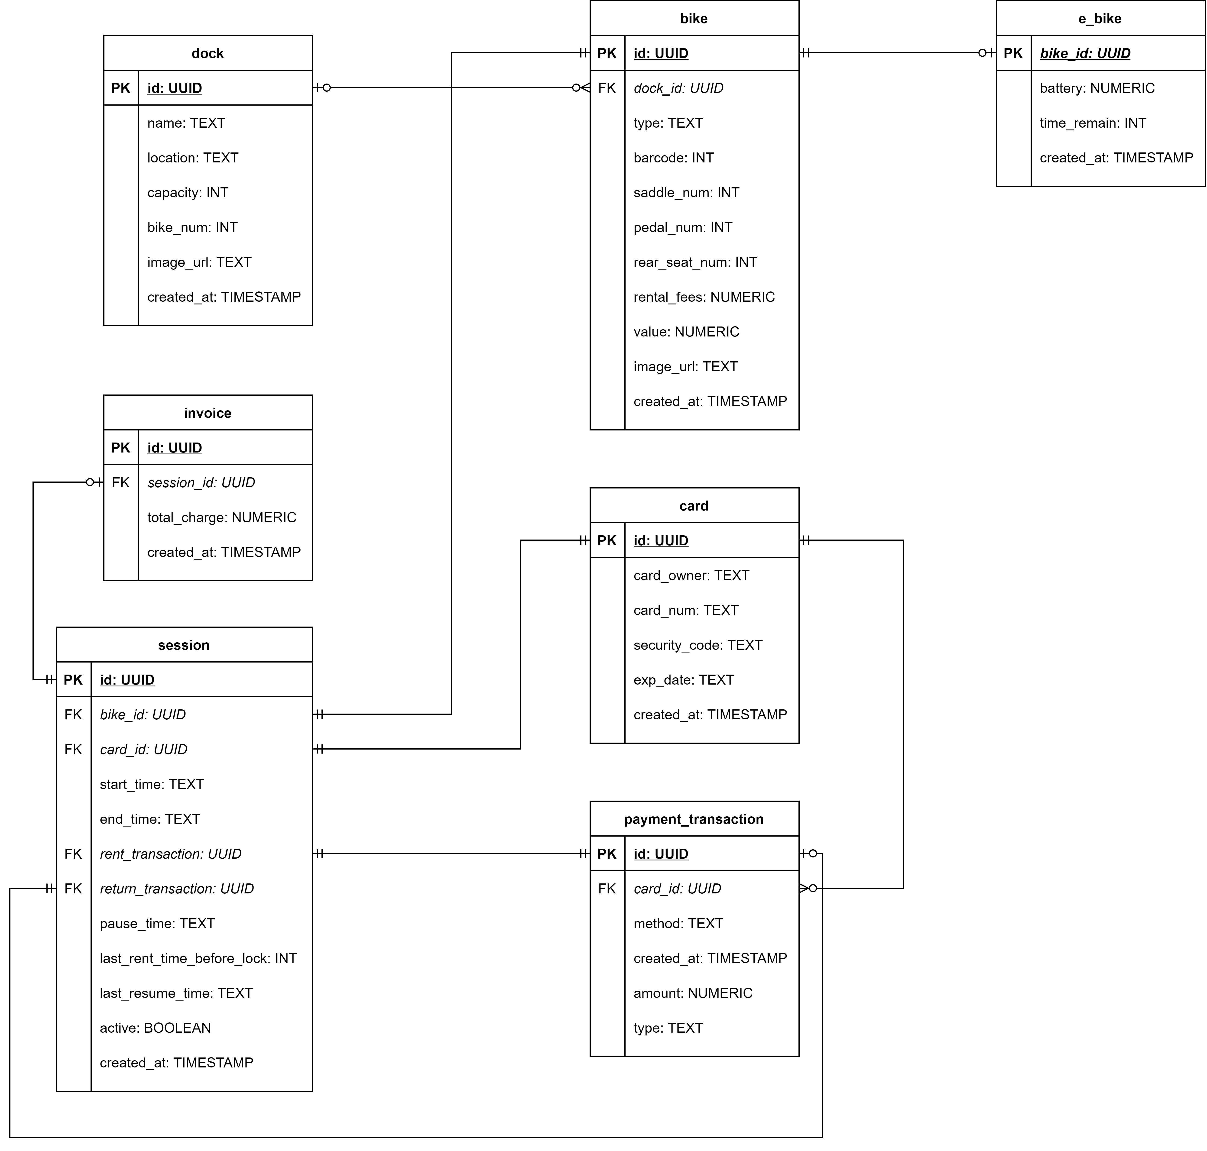

#### Physical Data Model

bike

|  |  |  |  |  |  |  |
| --- | --- | --- | --- | --- | --- | --- |
| # | PK | FK | Column Name | Data Type | Mandatory | Description |
| 1 | X |  | id | UUID | Yes | UUID |
| 2 |  |  | type | INT | Yes | Bike type, e.g., Standard Bike, E-Bike, … |
| 3 |  |  | barcode | INT | Yes | Barcode for renting |
| 4 |  |  | saddle_num | INT | Yes | Number of saddles |
| 5 |  |  | pedal_num | INT | Yes | Number of pedals |
| 6 |  |  | rear_seat_num | INT | Yes | Number of rear seats |
| 7 |  |  | value | INT | Yes | Value of the bike |
| 8 |  |  | rental_fees | INT | Yes | Rental fees |
| 9 |  | X | dock_id | UUID | No | Dock ID |
| 10 |  |  | image_url | TEXT | Yes | URL of image of bike |
| 11 |  |  | description | TEXT | No |  |
| 12 |  |  | created_at | TIMESTAMP WITH TIME ZONE | No | Created time |

e_bike

|  |  |  |  |  |  |  |
| --- | --- | --- | --- | --- | --- | --- |
| # | PK | FK | Column Name | Data Type | Mandatory | Description |
| 1 |  | X | bike_id | UUID | Yes | ID, same as ID of Bike of which type is E-Bike |
| 2 |  |  | battery | NUMERIC | Yes | Battery left percentage |
| 3 |  |  | time_remain | INT | Yes | Time remaining |
| 4 |  |  | created_at | TIMESTAMP WITH TIME ZONE | No | Created time |

dock

|  |  |  |  |  |  |  |
| --- | --- | --- | --- | --- | --- | --- |
| # | PK | FK | Column Name | Data Type | Mandatory | Description |
| 1 | X |  | id | UUID | Yes | UUID |
| 2 |  |  | name | TEXT | Yes | Name of the dock |
| 3 |  |  | location | TEXT | Yes | Address of the dock |
| 4 |  |  | capacity | INT | Yes | Total parking slot |
| 5 |  |  | bike_num | INT | Yes | Number of bike in the dock |
| 6 |  |  | image_url | TEXT | Yes | URL of image of dock |
| 7 |  |  | created_at | TIMESTAMP WITH TIME ZONE | No | Created time |
| 8 |  |  | taken_slot | integer | Yes | Taken slot in a dock |

session

|  |  |  |  |  |  |  |
| --- | --- | --- | --- | --- | --- | --- |
| # | PK | FK | Column Name | Data Type | Mandatory | Description |
| 1 | X |  | id | UUID | Yes | UUID |
| 2 |  | X | card_id | UUID | Yes | Card Id |
| 3 |  | X | bike_id | UUID | Yes | Bike Id |
| 4 |  |  | start_time | TEXT | No | Start time of session |
| 5 |  |  | end_time | TEXT | No | End time of session |
| 6 |  | X | rent_transaction_id | UUID | Yes | Renting transaction ID |
| 7 |  | X | return_transaction_id | UUID | No | Returning transaction ID |
| 8 |  |  | last_resume_time | TEXT | No | Last resume time |
| 9 |  |  | active | boolean | No | Session state |
| 10 |  |  | created_at | TIMESTAMP WITH TIME ZONE | No | Created time |
| 11 |  |  | last_rent_time_before_lock | INT | No | Last rent time before lock |

payment_transaction

|  |  |  |  |  |  |  |
| --- | --- | --- | --- | --- | --- | --- |
| # | PK | FK | Column Name | Data Type | Mandatory | Description |
| 1 | X |  | id | UUID | Yes | UUID |
| 2 |  | X | card_id | UUID | Yes | Card ID |
| 3 |  |  | type | TEXT | Yes | Type of the transaction |
| 4 |  |  | create_at | TIMESTAMP | Yes | Time when the transaction is created |
| 5 |  |  | amount | NUMERIC | Yes | Transaction amount |
| 6 |  |  | method | TEXT | Yes | Method of payment |
| 7 |  |  | created_at | TIMESTAMP WITH TIME ZONE | No | Created time |

card

|  |  |  |  |  |  |  |
| --- | --- | --- | --- | --- | --- | --- |
| # | PK | FK | Column Name | Data Type | Mandatory | Description |
| 1 | X |  | id | UUID | Yes | UUID |
| 2 |  |  | card_owner | TEXT | Yes | Full name of the card owner |
| 3 |  |  | card_num | TEXT | Yes | Card number, hashed |
| 4 |  |  | security_code | TEXT | Yes | Security code, hashed |
| 5 |  |  | exp_date | TEXT | Yes | Expiration date |
| 6 |  |  | created_at | TIMESTAMP WITH TIME ZONE | No | Created time |

invoice

|  |  |  |  |  |  |  |
| --- | --- | --- | --- | --- | --- | --- |
| # | PK | FK | Column Name | Data Type | Mandatory | Description |
| 1 | X |  | id | UUID | Yes | UUID |
| 2 |  | X | session_id | UUID | Yes | Session ID |
| 3 |  |  | total_charge | NUMERIC | No | Total charge money |
| 4 |  |  | created_at | TIMESTAMP WITH TIME ZONE | No | Created time |

SET statement_timeout = 0;

SET lock_timeout = 0;

SET idle_in_transaction_session_timeout = 0;

SET client_encoding = 'UTF8';

SET standard_conforming_strings = on;

SELECT pg_catalog.set_config('search_path', '', false);

SET check_function_bodies = false;

SET xmloption = content;

SET client_min_messages = warning;

SET row_security = off;

CREATE EXTENSION IF NOT EXISTS adminpack WITH SCHEMA pg_catalog;

COMMENT ON EXTENSION adminpack IS 'administrative functions for PostgreSQL';

CREATE EXTENSION IF NOT EXISTS "uuid-ossp" WITH SCHEMA public;

COMMENT ON EXTENSION "uuid-ossp" IS 'generate universally unique identifiers (UUIDs)';

SET default_tablespace = '';

SET default_table_access_method = heap;

DROP TABLE IF EXISTS public.invoice;

DROP TABLE IF EXISTS public.session;

DROP TABLE IF EXISTS public.payment_transaction;

DROP TABLE IF EXISTS public.card;

DROP TABLE IF EXISTS public.e_bike;

DROP TABLE IF EXISTS public.bike;

DROP TABLE IF EXISTS public.dock;

CREATE TABLE public.bike

(

    id            uuid                     DEFAULT public.uuid_generate_v4() NOT NULL,

    type          integer                  DEFAULT 1                         NOT NULL,

    barcode       integer                                                    NOT NULL,

    saddle_num    integer                  DEFAULT 1                         NOT NULL,

    pedal_num     integer                  DEFAULT 1                         NOT NULL,

    rear_seat_num integer                  DEFAULT 1                         NOT NULL,

    value         integer                                                    NOT NULL,

    rental_fees   integer                                                    NOT NULL,

    image_url     text                     DEFAULT ''::text,

    created_at    timestamp with time zone DEFAULT CURRENT_TIMESTAMP,

    description   text,

    dock_id       uuid

);

ALTER TABLE public.bike

    OWNER TO postgres;

CREATE TABLE public.card

(

    id            uuid                     DEFAULT public.uuid_generate_v4() NOT NULL,

    card_num      text                                                       NOT NULL UNIQUE,

    card_owner    text                                                       NOT NULL,

    security_code text                                                       NOT NULL,

    exp_date      text                                                       NOT NULL,

    created_at    timestamp with time zone DEFAULT CURRENT_TIMESTAMP

);

ALTER TABLE public.card

    OWNER TO postgres;

CREATE TABLE public.dock

(

    id         uuid                     DEFAULT public.uuid_generate_v4() NOT NULL,

    name       text    NOT NULL,

    location   text    NOT NULL,

    taken_slot integer NOT NULL         DEFAULT 0,

    capacity   integer NOT NULL,

    image_url  text                     DEFAULT ''::text,

    created_at timestamp with time zone DEFAULT CURRENT_TIMESTAMP

);

ALTER TABLE public.dock

    OWNER TO postgres;

CREATE TABLE public.e_bike

(

    bike_id     uuid          NOT NULL,

    battery     numeric(3, 1) NOT NULL,

    time_remain integer       NOT NULL,

    created_at  timestamp with time zone DEFAULT CURRENT_TIMESTAMP

);

ALTER TABLE public.e_bike

    OWNER TO postgres;

CREATE TABLE public.invoice

(

    id           uuid                     DEFAULT public.uuid_generate_v4() NOT NULL,

    session_id   uuid                                                       NOT NULL,

    total_charge numeric,

    created_at   timestamp with time zone DEFAULT CURRENT_TIMESTAMP

);

ALTER TABLE public.invoice

    OWNER TO postgres;

CREATE TABLE public.payment_transaction

(

    id             uuid                     DEFAULT public.uuid_generate_v4() NOT NULL,

    card_id        uuid                                                       NOT NULL,

    type           text                                                       NOT NULL,

    amount         numeric                                                    NOT NULL,

    method         text,

    transaction_id text                                                       NOT NULL,

    created_at     timestamp with time zone DEFAULT CURRENT_TIMESTAMP

);

ALTER TABLE public.payment_transaction

    OWNER TO postgres;

CREATE TABLE public.session

(

    id                         uuid                     DEFAULT public.uuid_generate_v4() NOT NULL,

    card_id                    uuid                                                       NOT NULL,

    bike_id                    uuid                                                       NOT NULL,

    rent_transactionid         uuid                                                       NOT NULL,

    return_transactionid       uuid,

    last_rent_time_before_lock INT                      DEFAULT 0,

    active                     boolean                  DEFAULT true,

    start_time                 Text,

    last_resume_time           Text,

    end_time                   Text,

    created_at                 timestamp with time zone DEFAULT CURRENT_TIMESTAMP

);

ALTER TABLE public.session

    OWNER TO postgres;

CREATE OR REPLACE FUNCTION public.bike_dock_change()

    RETURNS TRIGGER

    LANGUAGE PLPGSQL

AS

$$

BEGIN

    IF OLD.dock_id IS NOT NULL AND NEW.dock_id IS NULL THEN

        UPDATE public.dock

        SET taken_slot = taken_slot - 1

        WHERE id = OLD.dock_id;

    END IF;

    IF OLD.dock_id IS NULL AND NEW.dock_id IS NOT NULL THEN

        UPDATE public.dock

        SET taken_slot = taken_slot + 1

        WHERE id = NEW.dock_id;

    END IF;

    RETURN NEW;

END;

$$;

CREATE TRIGGER dock_changes

    AFTER UPDATE

    ON public.bike

    FOR EACH ROW

EXECUTE PROCEDURE public.bike_dock_change();

CREATE OR REPLACE FUNCTION public.insert_new_bike()

    RETURNS TRIGGER

    LANGUAGE PLPGSQL

AS

$$

BEGIN

    IF NEW.dock_id IS NOT NULL THEN

        UPDATE public.dock

        SET taken_slot = taken_slot + 1

        WHERE id = NEW.dock_id;

    END IF;

    RETURN NEW;

END;

$$;

CREATE TRIGGER bike_insert

    AFTER INSERT

    ON public.bike

    FOR EACH ROW

EXECUTE PROCEDURE public.insert_new_bike();

-- DOCK

INSERT INTO public.dock (id, name, location, capacity, image_url, created_at)

VALUES ('4a4e10eb-1de2-411f-a35b-fc5be0cc7393', 'ECO Bike Park 1', 'Location 1', 200, '',

        '2020-12-03 21:52:19.458054+07');

INSERT INTO public.dock (id, name, location, capacity, image_url, created_at)

VALUES ('012b8b33-32a3-4c15-ba0f-ba3204e119b0', 'ECO Bike Park 2', 'Location 2', 200, '',

        '2020-12-03 21:52:30.624056+07');

INSERT INTO public.dock (id, name, location, capacity, image_url, created_at)

VALUES ('31b2f5d7-dcbc-428a-8be5-3f49fa5a3573', 'ECO Bike Park 3', 'Location 3', 100, '',

        '2020-12-03 21:52:36.709013+07');

-- BIKE

INSERT INTO public.bike (id, type, barcode, saddle_num, pedal_num, rear_seat_num, value, rental_fees, image_url,

                         created_at, description, dock_id)

VALUES ('078a3525-4146-49ba-9c4c-9caf1678ddcd', 1, 467295, 1, 1, 1, 1000000, 25000,

        'assets\images\bikes\StandardBike.png', '2020-12-03 21:53:34.242179+07', NULL,

        '012b8b33-32a3-4c15-ba0f-ba3204e119b0');

INSERT INTO public.bike (id, type, barcode, saddle_num, pedal_num, rear_seat_num, value, rental_fees, image_url,

                         created_at, description, dock_id)

VALUES ('1be8a4e1-5eb6-48f6-b9ff-5f67a6c45f85', 4, 452593, 2, 2, 1, 8000000, 50000,

        'assets\images\bikes\TwinElectricalBike.png', '2020-12-03 21:58:17.775008+07', NULL,

        '31b2f5d7-dcbc-428a-8be5-3f49fa5a3573');

INSERT INTO public.bike (id, type, barcode, saddle_num, pedal_num, rear_seat_num, value, rental_fees, image_url,

                         created_at, description, dock_id)

VALUES ('31e1ac5c-a755-4946-aa1b-9cf8989ee87f', 1, 784318, 1, 1, 1, 1000000, 25000,

        'assets\images\bikes\StandardBike.png', '2020-12-03 21:54:50.621477+07', NULL,

        '4a4e10eb-1de2-411f-a35b-fc5be0cc7393');

INSERT INTO public.bike (id, type, barcode, saddle_num, pedal_num, rear_seat_num, value, rental_fees, image_url,

                         created_at, description, dock_id)

VALUES ('524ccbd1-c1d5-47d9-9c28-827f88a9adcd', 3, 697316, 1, 1, 1, 6000000, 50000,

        'assets\images\bikes\ElectricalBike.png', '2020-12-03 21:56:37.492976+07', NULL,

        '012b8b33-32a3-4c15-ba0f-ba3204e119b0');

INSERT INTO public.bike (id, type, barcode, saddle_num, pedal_num, rear_seat_num, value, rental_fees, image_url,

                         created_at, description, dock_id)

VALUES ('78270ffe-be03-4e83-b466-b9c2e274a976', 4, 228636, 2, 2, 1, 8000000, 50000,

        'assets\images\bikes\TwinElectricalBike.png', '2020-12-03 21:57:52.695281+07', NULL,

        '012b8b33-32a3-4c15-ba0f-ba3204e119b0');

INSERT INTO public.bike (id, type, barcode, saddle_num, pedal_num, rear_seat_num, value, rental_fees, image_url,

                         created_at, description, dock_id)

VALUES ('9ef7ceb8-38c9-4d56-9fb6-1ddfd0364f46', 1, 216064, 1, 1, 1, 1000000, 25000,

        'assets\images\bikes\StandardBike.png', '2020-12-03 21:54:09.924574+07', NULL,

        '31b2f5d7-dcbc-428a-8be5-3f49fa5a3573');

INSERT INTO public.bike (id, type, barcode, saddle_num, pedal_num, rear_seat_num, value, rental_fees, image_url,

                         created_at, description, dock_id)

VALUES ('b3af2957-1a4d-4c64-8cef-7b0b393625ce', 2, 527841, 2, 2, 1, 4000000, 50000, 'assets\images\bikes\TwinBike.png',

        '2020-12-03 21:55:52.16724+07', NULL, '31b2f5d7-dcbc-428a-8be5-3f49fa5a3573');

INSERT INTO public.bike (id, type, barcode, saddle_num, pedal_num, rear_seat_num, value, rental_fees, image_url,

                         created_at, description, dock_id)

VALUES ('cc2e033a-7505-4a66-a639-4d9cd35f9d6d', 2, 826086, 2, 2, 1, 4000000, 50000, 'assets\images\bikes\TwinBike.png',

        '2020-12-03 21:55:25.58271+07', NULL, '4a4e10eb-1de2-411f-a35b-fc5be0cc7393');

INSERT INTO public.bike (id, type, barcode, saddle_num, pedal_num, rear_seat_num, value, rental_fees, image_url,

                         created_at, description, dock_id)

VALUES ('d06ba58c-4759-419d-85c3-07b3f738f500', 1, 533503, 1, 1, 1, 1000000, 25000,

        'assets\images\bikes\StandardBike.png', '2020-12-03 21:53:49.299133+07', NULL,

        '012b8b33-32a3-4c15-ba0f-ba3204e119b0');

INSERT INTO public.bike (id, type, barcode, saddle_num, pedal_num, rear_seat_num, value, rental_fees, image_url,

                         created_at, description, dock_id)

VALUES ('e50afbf2-e6f7-46c6-a9e3-82505901af21', 3, 188831, 1, 1, 1, 6000000, 50000,

        'assets\images\bikes\ElectricalBike.png', '2020-12-03 21:56:55.635597+07', NULL,

        '012b8b33-32a3-4c15-ba0f-ba3204e119b0');

-- E-BIKE

INSERT INTO public.e_bike (bike_id, battery, time_remain, created_at)

VALUES ('1be8a4e1-5eb6-48f6-b9ff-5f67a6c45f85', 99.9, 360, '2020-12-11 13:51:02.69043+07');

INSERT INTO public.e_bike (bike_id, battery, time_remain, created_at)

VALUES ('524ccbd1-c1d5-47d9-9c28-827f88a9adcd', 20.0, 72, '2020-12-11 13:52:01.710722+07');

INSERT INTO public.e_bike (bike_id, battery, time_remain, created_at)

VALUES ('78270ffe-be03-4e83-b466-b9c2e274a976', 40.0, 144, '2020-12-11 13:52:01.710722+07');

INSERT INTO public.e_bike (bike_id, battery, time_remain, created_at)

VALUES ('e50afbf2-e6f7-46c6-a9e3-82505901af21', 80.0, 288, '2020-12-11 13:52:01.710722+07');

ALTER TABLE ONLY public.bike

    ADD CONSTRAINT bike_pk PRIMARY KEY (id);

ALTER TABLE ONLY public.card

    ADD CONSTRAINT card_pk PRIMARY KEY (id);

ALTER TABLE ONLY public.dock

    ADD CONSTRAINT dock_pk PRIMARY KEY (id);

ALTER TABLE ONLY public.e_bike

    ADD CONSTRAINT e_bike_pk PRIMARY KEY (bike_id);

ALTER TABLE ONLY public.invoice

    ADD CONSTRAINT invoice_pk PRIMARY KEY (id);

ALTER TABLE ONLY public.payment_transaction

    ADD CONSTRAINT payment_transaction_pk PRIMARY KEY (id);

ALTER TABLE ONLY public.payment_transaction

    ADD CONSTRAINT payment_transaction_fk FOREIGN KEY (card_id) REFERENCES public.card (id) ON DELETE CASCADE;

ALTER TABLE ONLY public.session

    ADD CONSTRAINT session_pk PRIMARY KEY (id);

ALTER TABLE ONLY public.bike

    ADD CONSTRAINT bike_fk FOREIGN KEY (dock_id) REFERENCES public.dock (id) ON DELETE CASCADE;

ALTER TABLE ONLY public.e_bike

    ADD CONSTRAINT e_bike_fk FOREIGN KEY (bike_id) REFERENCES public.bike (id) ON DELETE CASCADE;

ALTER TABLE ONLY public.invoice

    ADD CONSTRAINT invoice_fk FOREIGN KEY (session_id) REFERENCES public.session (id);

ALTER TABLE ONLY public.session

    ADD CONSTRAINT session_fk1 FOREIGN KEY (card_id) REFERENCES public.card (id);

ALTER TABLE ONLY public.session

    ADD CONSTRAINT session_fk2 FOREIGN KEY (bike_id) REFERENCES public.bike (id);

ALTER TABLE ONLY public.session

    ADD CONSTRAINT session_fk3 FOREIGN KEY (rent_transactionid) REFERENCES public.payment_transaction (id);

ALTER TABLE ONLY public.session

    ADD CONSTRAINT session_fk4 FOREIGN KEY (return_transactionid) REFERENCES public.payment_transaction (id);

## Non-Database Management System Files

## Class Design

### General Class Diagram

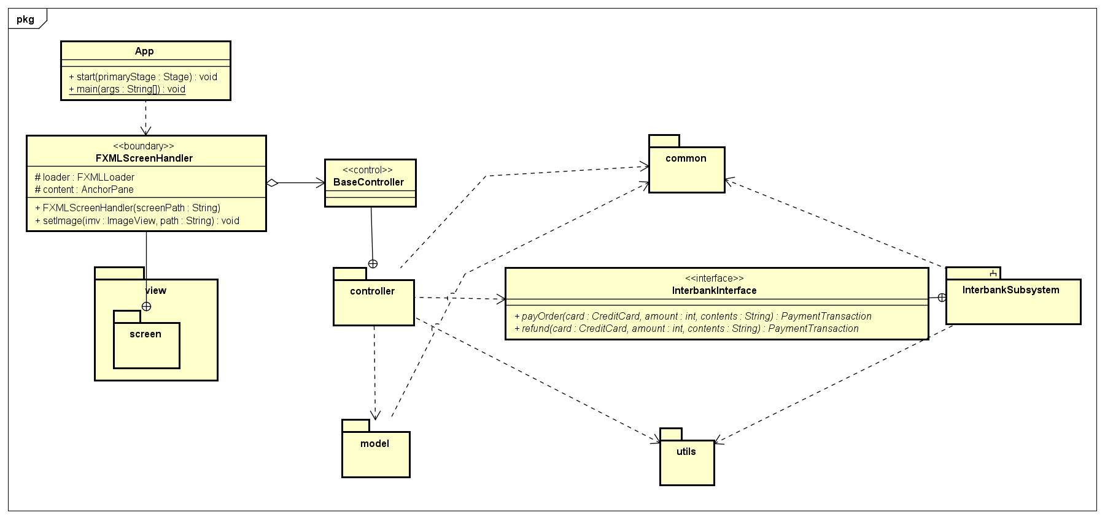

### Class Diagrams

#### Class Diagram for Package “controller”

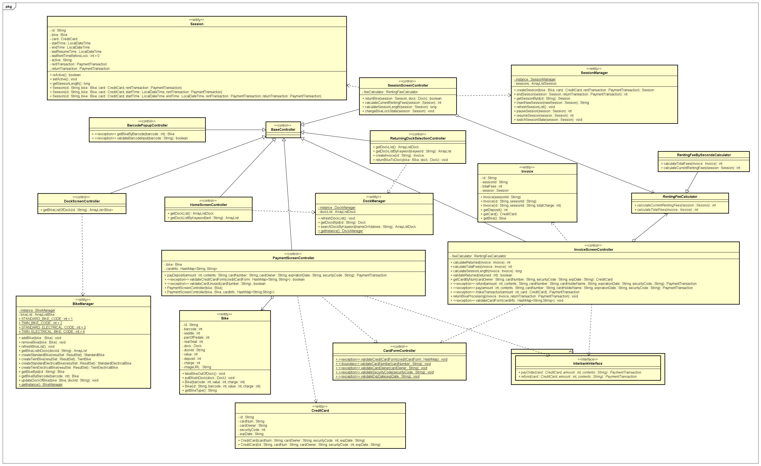

#### Class Diagram for Package “model”

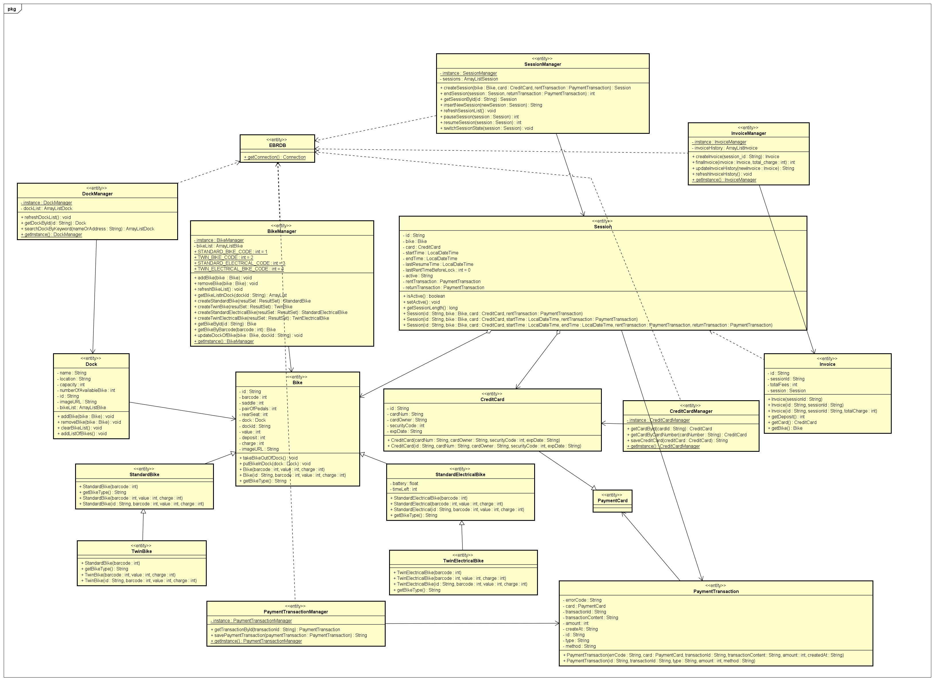

#### Class Diagram for Package “view”

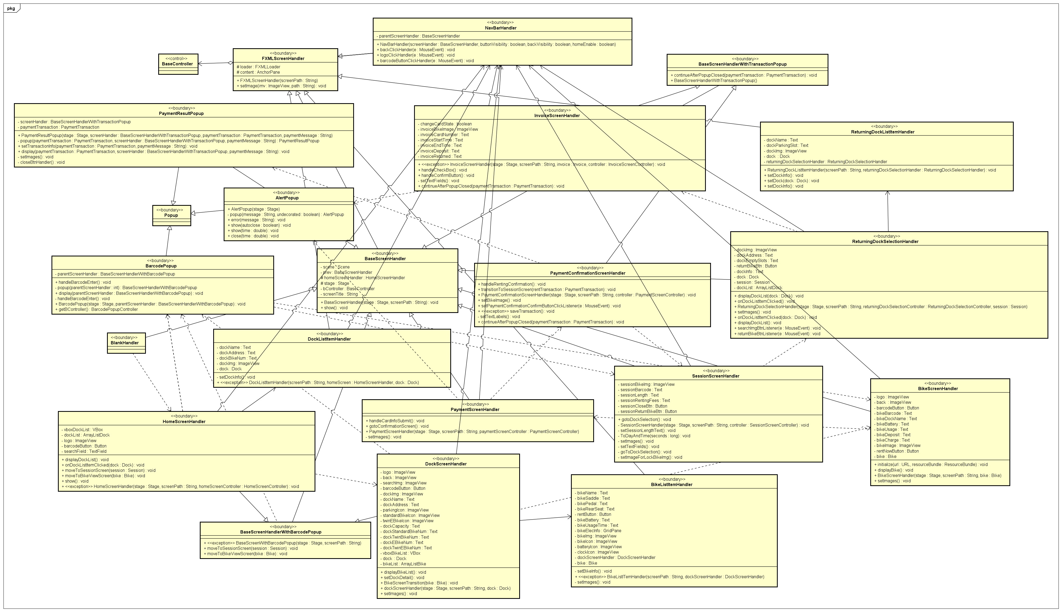

#### Class Diagram for Package “utils”

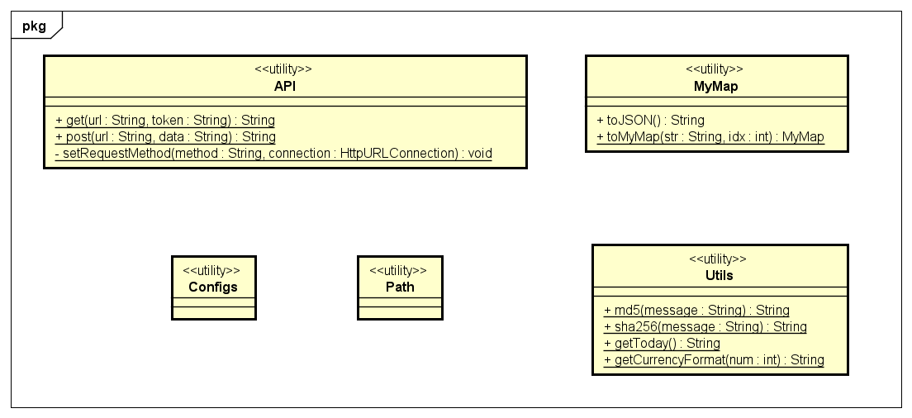

#### Class Diagram for Subsystem “interbank”

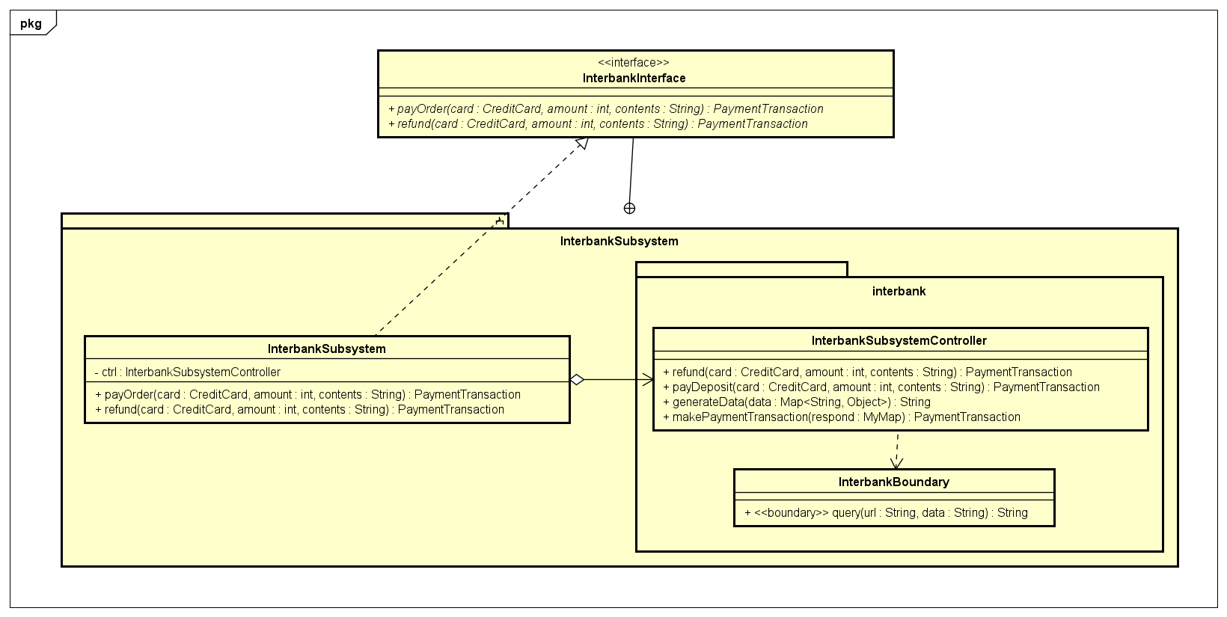

### Class Design

#### Class “App”

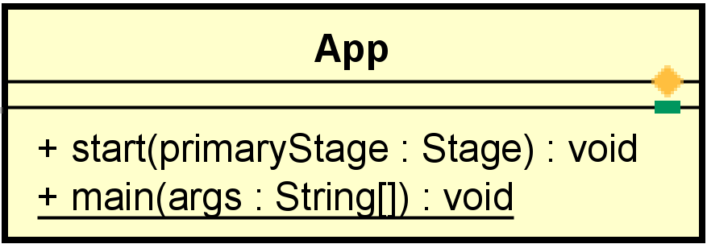

**Attribute**

None

**Operation**

|  |  |  |  |
| --- | --- | --- | --- |
| # | Name | Return type | Description |
| 1 | start | void | javaFx framwork will call this |
| 2 | main | void | execution entry |

Parameter:

stage: javaFx main stage

args: environment variable

Exception:

None

**Method**

None

**State**

None

#### Class “BarcodePopupController”

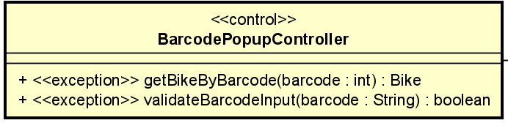

**Attribute**

None

**Operation**

|  |  |  |  |
| --- | --- | --- | --- |
| # | Name | Return type | Desciption |
| 1 | getBikeByBarcode | Bike | Get bike by using barcode |
| 2 | ValidateBarcodeInput | boolean | Checks if barcode is entered or not |

Parameter:

barcode– int

Barcode - string

Exception:

BarcodeNotFoundException

NullBarcodeException

InvalidBarcodeException

**Method**

None

**State**

None

#### Class “BaseController”

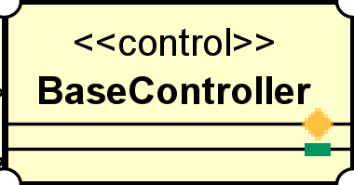

**Attribute**

None

**Operation**

None

Parameter:

None

Exception:

None

**Method**

None

**State**

None

#### Class “DockScreenController”

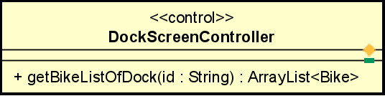

**Attribute**

None

**Operation**

|  |  |  |  |
| --- | --- | --- | --- |
| # | Name | Return type | Desciption |
| 1 | getBikeListOfDock | ArrayList | Get bike list by using dock id |

Parameter:

Id – dock id

Exception:

None

**Method**

None

**State**

None

#### Class “HomeScreenController”

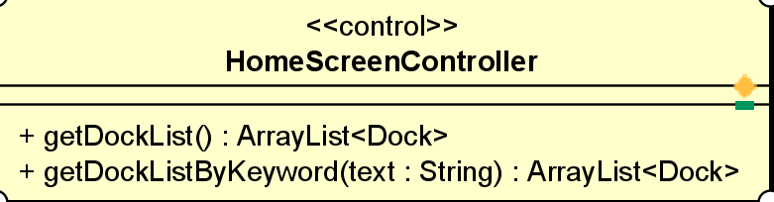

**Attribute**

None

**Operation**

|  |  |  |  |
| --- | --- | --- | --- |
| # | Name | Return type | Desciption |
| 1 | getDockList | ArrayList | Get dock list |
| 2 | getDockListByKeyword | ArrayList | Get dock list by keyword |

Parameter:

Text - keyword

Exception:

None

**Method**

None

**State**

None

#### Class “InvoiceScreenController”

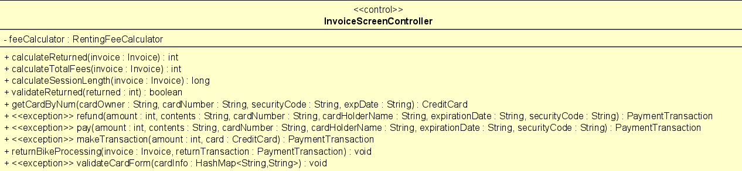

**Attribute**

|  |  |  |  |  |
| --- | --- | --- | --- | --- |
| # | Name | Data type | Default value | Description |
| 1 | feeCalculator | RentingFeeCalculator | new RentingFeeBySecondsCalculator | calculate fee |

**Operation**

|  |  |  |  |
| --- | --- | --- | --- |
| # | Name | Return type | Desciption |
| 1 | calculateReturned | Int | Calculate returned after deducting renting fees |
| 2 | calculateTotalFees | Int | Calculate total fees |
| 3 | calculateSessionLength | long | Session length |
| 4 | refund | PaymentTransaction | Create return transaction |
| 5 | validateReturned | boolean | Check returned validity |
| 6 | getCardByNum | CreditCard | Get credit card info |
| 7 | refund | PaymentTransaction | Setup Return transaction |
| 8 | pay | PaymentTransaction | Setup transaction |
| 9 | makeTransaction | PaymentTransaction | Proceed transaction |
| 10 | validateCardForm | void | Check card form validity |

Parameter:

Invoice

Amount

Contents

CardNumber

CardOwner

ExpirationDate

SecurityCode

Returned

Exception:

PaymentException

NullCardNumberException

NullCardOwnerException

NullExpDateException

NullSecurityCodeException

CardExpiredException

**Method**

None

**State**

None

#### Class “PaymentScreenController”

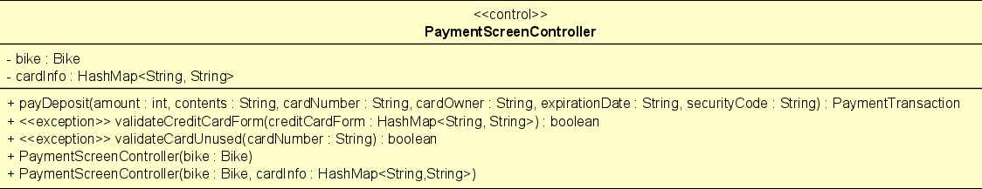

**Attribute**

|  |  |  |  |  |
| --- | --- | --- | --- | --- |
| # | Name | Data type | Default value | Description |
| 1 | bike | Bike | NULL | bike |
| 2 | cardInfo | HashMap<String, String> | NULL | Card info |

**Operation**

|  |  |  |  |
| --- | --- | --- | --- |
| # | Name | Return type | Desciption |
| 1 | payDeposit | PaymentTransaction | Set rent transaction |
| 2 | validateCreditCardForm | boolean | Check creditcard form |
| 3 | validateCardUnused | boolean | Check creditcard used or not |

Parameter:

Amount

Contents

CardNumber

CreditCardForm

CardInfo

Bike

Exception:

None

**Method**

None

**State**

None

#### Class “Class “ReturningDockSelectionController”

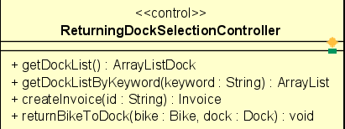

**Attribute**

None

**Operation**

|  |  |  |  |
| --- | --- | --- | --- |
| # | Name | Return type | Desciption |
| 1 | getDockList | ArrayList<Dock> | Get dock list |
| 2 | getDockListByKeyWord | ArrayList<Dock> | Get dock list by keyword |
| 3 | createInvoice | Invoice | Create new invoice |
| 4 | returnBikeToDock | void | Return bike to the chosen dock |

Parameter:

Keyword

Id

Bike

Dock

Exception:

None

**Method**

None

**State**

None

#### Class “SessionScreenController”

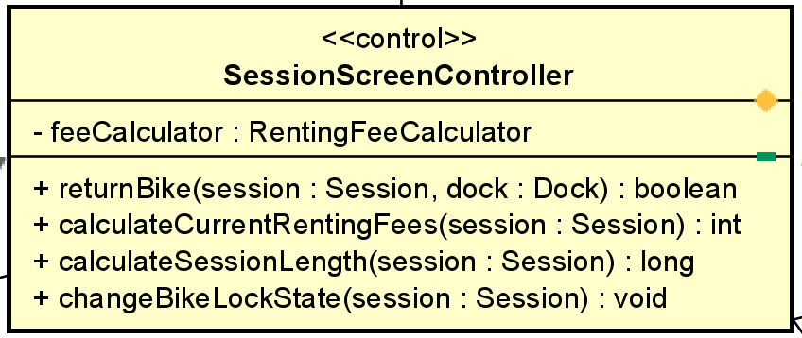

**Attribute**

|  |  |  |  |  |
| --- | --- | --- | --- | --- |
| # | Name | Data type | Default value | Description |
| 1 | feeCalculator | RentingFeeCalculator | new RentingFeeBySecondsCalculator | calculate fee |

**Operation**

|  |  |  |  |
| --- | --- | --- | --- |
| # | Name | Return type | Desciption |
| 1 | returnBike | boolean | Check if bike is available |
| 2 | calculateCurrenRentingFees | int | Calculate current renting fees |
| 3 | calculateSessionLength | long | Calculate session length |
| 4 | changeBikeLockState | void | Change bike lock state |

Parameter:

Session

Dock

Exception:

None

**Method**

None

**State**

None

#### Class “CardFormController”

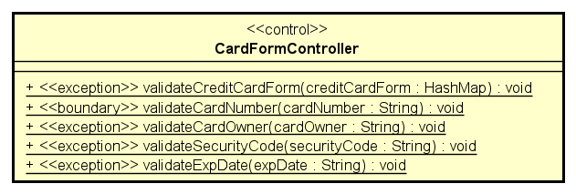

**Attribute**

None

**Operation**

|  |  |  |  |
| --- | --- | --- | --- |
| # | Name | Return type | Desciption |
| 1 | validateCreditCardForm | void | Check if card is valid |
| 2 | validateCardNumber | void | Validate card number |
| 3 | validateCardOwner | void | Validate card owner |
| 4 | validateSecurityCode | void | Validate security code |
| 5 | validateExpDate | void | Validate exp date |

Parameter:

CreditCardForm

CardNumber

CardOwner

SecurityCode

expDate

Exception:

None

**Method**

None

**State**

None

#### Class “RentingFeeBySecondsCalculator”

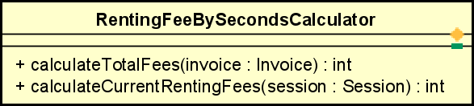

**Attribute**

None

**Operation**

|  |  |  |  |
| --- | --- | --- | --- |
| # | Name | Return type | Desciption |
| 1 | calculateTotalFees | int | Calculate total fees |
| 2 | calculateCurrentRentingFees | int | Calculate current renting fees |

Parameter:

Invoice

session

Exception:

None

**Method**

None

**State**

None

#### Class “RentingFeeCalculator”

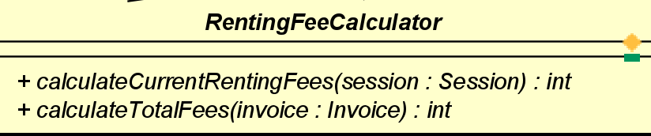

**Attribute**

None

**Operation**

|  |  |  |  |
| --- | --- | --- | --- |
| # | Name | Return type | Desciption |
| 1 | calculateTotalFees | int | Calculate total fees |
| 2 | calculateCurrentRentingFees | int | Calculate current renting fees |

Parameter:

Invoice

session

Exception:

None

**Method**

None

**State**

None

#### Class “Bike”

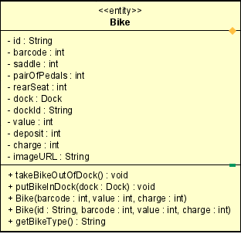

**Attribute**

|  |  |  |  |  |
| --- | --- | --- | --- | --- |
| # | Name | Data type | Default value | Description |
| 1 | id | String | NULL | Bike id |
| 2 | barcode | int | NULL | barcode |
| 3 | saddle | int | NULL | saddle |
| 4 | pairOfPedals | int | NULL | Pair of pedals |
| 5 | rearSeat | int | NULL | Number of rear seats |
| 6 | dock | Dock | NULL | dock |
| 7 | dockId | String | NULL | Dock id |
| 8 | value | int | NULL | value |
| 9 | doposit | int | NULL | deposit |
| 10 | charge | int | NULL | charge |
| 11 | imageURL | String | NULL | Image URL |

**Operation**

|  |  |  |  |
| --- | --- | --- | --- |
| # | Name | Return type | Desciption |
| 1 | takeBikeOutOfDock | void | Take bike out of dock |
| 2 | putBikeInDock | void | Put bike to a dock |
| 3 | getBikeType | String | Get bike type |

Parameter:

dock

Barcode

Value

Charge

id

Exception:

None

**Method**

None

**State**

None

#### Class “BikeManager”

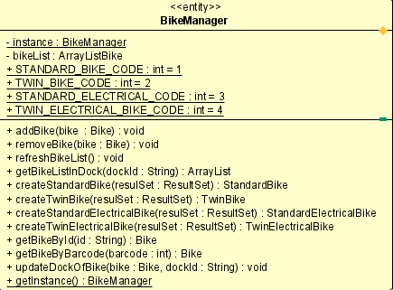

**Attribute**

|  |  |  |  |  |
| --- | --- | --- | --- | --- |
| # | Name | Data type | Default value | Description |
| 1 | instance | BikeManager | NULL | Bike instance |
| 2 | bikeList | ArrayList | NULL | Bike list |
| 3 | STANDARD_BIKE_CODE | int | 1 | Code of standard bike |
| 4 | TWIN_BIKE_CODE | int | 2 | Code of twin bike |
| 5 | STANDARD_ELECTRICAL_BIKE_CODE | int | 3 | Code of standard e bike |
| 6 | TWIN_ELEC TRICAL_BIKE_CODE | int | 4 | Code of twin e bike |

**Operation**

|  |  |  |  |
| --- | --- | --- | --- |
| # | Name | Return type | Desciption |
| 1 | addBike | void | Add bike |
| 2 | removeBike | void | Remove bike |
| 3 | refreshBikeList | void | Refresh bike list |
| 4 | getBikeListInDock | ArrayList | Get bike list in dock |
| 5 | createStandardBike | StandardBike | Create standard bike |
| 6 | createTwinBike | TwinBike | Create twin bike |
| 7 | createStandardEBike | StandardEBike | Create standard e bike |
| 8 | createTwinEBike | TwinEBike | Create twin e bike |
| 9 | getBikeById | Bike | Get bike by id |
| 10 | getBikeByBarcode | Bike | Get bike by barcode |
| 11 | updateDockOfBike | void | Update dock |
| 12 | getInstance | BikeManager | Get bike instance |

Parameter:

bike

DockId

ResultSet

Id – bikeId

barcode

Exception:

None

**Method**

None

**State**

None

#### Class “StandardBike”

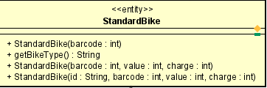

**Attribute**

None

**Operation**

|  |  |  |  |
| --- | --- | --- | --- |
| # | Name | Return type | Desciption |
| 1 | getBikeType | String | Get bike type |

Parameter:

None

Exception:

None

**Method**

None

**State**

None

#### Class “StandardElectricalBike”

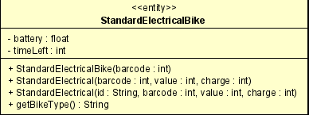

**Attribute**

|  |  |  |  |  |
| --- | --- | --- | --- | --- |
| # | Name | Data type | Default value | Description |
| 1 | battery | float | 100.0 | battery remained |
| 2 | timeLeft | int | NULL | usage time base on battery and bike |

**Operation**

None

Parameter:

None

Exception:

None

**Method**

None

**State**

None

#### Class “TwinBike”

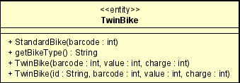

**Attribute**

None

**Operation**

|  |  |  |  |
| --- | --- | --- | --- |
| # | Name | Return type | Desciption |
| 1 | getBikeType | String | Get bike type |

Parameter:

None

Exception:

None

**Method**

None

**State**

None

#### Class “TwinElectricalBike”

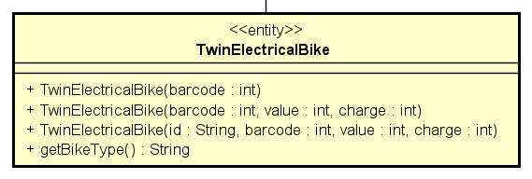

**Attribute**

None

**Operation**

|  |  |  |  |
| --- | --- | --- | --- |
| # | Name | Return type | Desciption |
| 1 | getBikeType | String | Get bike type |

Parameter:

None

Exception:

None

**Method**

None

**State**

None

#### Class “EBRDB”

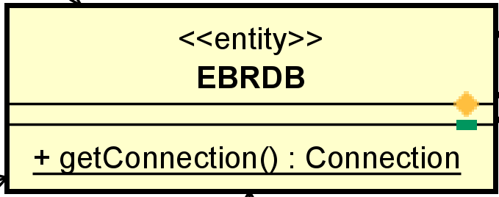

**Attribute**

None

**Operation**

|  |  |  |  |
| --- | --- | --- | --- |
| # | Name | Return type | Desciption |
| 1 | getConnection | Connect | get a connection to PostgreSQL database |

Parameter:

None

Exception:

None

**Method**

None

**State**

None

#### Class “Dock”

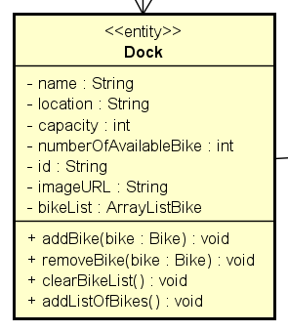 3

**Attribute**

|  |  |  |  |  |
| --- | --- | --- | --- | --- |
| # | Name | Data type | Default value | Description |
| 1 | name | String | NULL | Name of dock |
| 2 | location | String | NULL | Dock location |
| 3 | capacity | int | NULL | Dock size |
| 4 | numberOfAvailableBike | int | NULL | Number of available bikes |
| 5 | id | String | NULL | Dock id |
| 6 | imageURL | String | NULL | Dock image |
| 7 | bikeList | ArrayList<Bike> | NULL | Bike list in dock |

**Operation**

|  |  |  |  |
| --- | --- | --- | --- |
| # | Name | Return type | Desciption |
| 1 | addBike | void | Add bike to dock |
| 2 | removeBike | void | Remove bike out of dock |
| 3 | clearBikeList | void | Clear bike list in dock |
| 4 | addListOfBike | void | Add bike list to dock |

Parameter:

bike

Exception:

None

**Method**

None

**State**

None

#### Class “DockManager”

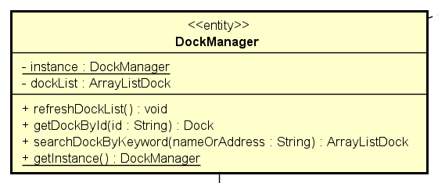

**Attribute**

|  |  |  |  |  |
| --- | --- | --- | --- | --- |
| # | Name | Data type | Default value | Description |
| 1 | instance | DockManager | NULL | Instance of a dock |
| 2 | dockList | ArrayList<Dock> | NULL | Dock list |

**Operation**

|  |  |  |  |
| --- | --- | --- | --- |
| # | Name | Return type | Desciption |
| 1 | refreshDockList | void | Refresh dock list |
| 2 | getDockById | Dock | Get dock by id |
| 3 | searchDockByKeyword | ArrayList<Dock> | Get docks by keyword |
| 4 | getInstance | DockManager | Get dock instance |

Parameter:

Id - dock id

NameOfAddress – dock address

Exception:

None

**Method**

None

**State**

None

#### Class “Invoice”

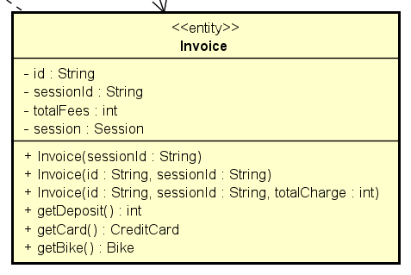

**Attribute**

|  |  |  |  |  |
| --- | --- | --- | --- | --- |
| # | Name | Data type | Default value | Description |
| 1 | id | String | NULL | Invoice id |
| 2 | sessionId | String | NULL | Session id |
| 3 | totalFees | int | NULL | Total charge |
| 4 | session | Session | NULL | Session correspond to invoice |

**Operation**

|  |  |  |  |
| --- | --- | --- | --- |
| # | Name | Return type | Desciption |
| 1 | getDeposit | int | Get deposit |
| 2 | getCard | CreditCard | Get credit card |
| 3 | getBike | Bike | Get bike |

Parameter:

None

Exception:

None

**Method**

None

**State**

None

#### Class “InvoiceManager”

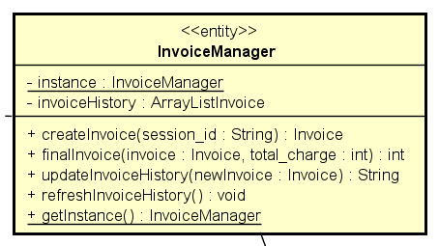

**Attribute**

|  |  |  |  |  |
| --- | --- | --- | --- | --- |
| # | Name | Data type | Default value | Description |
| 1 | instance | DockManager | NULL | Instance of a dock |
| 2 | invoiceHistory | ArrayList<Invoice> | NULL | Invoice History |

**Operation**

|  |  |  |  |
| --- | --- | --- | --- |
| # | Name | Return type | Desciption |
| 1 | createInvoice | Invoice | Create new invoice |
| 2 | finalInvoice | int | Complete invoice |
| 3 | updateInvoiceHistory | String | Update invoice history |
| 4 | refreshInvoiceHistory | void | Refresh invoice history |
| 5 | getInstance | InvoiceManager | Get invoice instance |

Parameter:

Session_id

Invoice

Total_charge

newInvoice

Exception:

None

**Method**

None

**State**

None

#### Class “CreditCard”

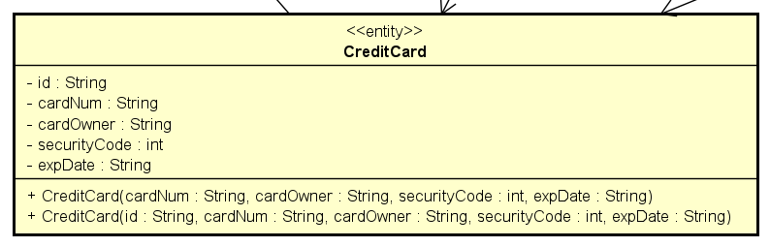

**Attribute**

|  |  |  |  |  |
| --- | --- | --- | --- | --- |
| # | Name | Data type | Default value | Description |
| 1 | id | String | NULL | Card id |
| 2 | cardNum | String | NULL | Card number |
| 3 | cardOwner | String | NULL | Card owner’s name |
| 4 | securityCode | int | NULL | Card security code |
| 5 | expDate | String | NULL | Card exp date |

**Operation**

None

Parameter:

None

Exception:

None

**Method**

None

**State**

None

#### Class “CreditCardManager”

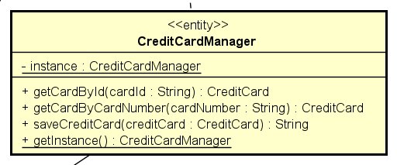

**Attribute**

|  |  |  |  |  |
| --- | --- | --- | --- | --- |
| # | Name | Data type | Default value | Description |
| 1 | instance | CreditCardManager | NULL | Instance of a card |

**Operation**

|  |  |  |  |
| --- | --- | --- | --- |
| # | Name | Return type | Desciption |
| 1 | getCardById | CreditCard | Get card by id |
| 2 | getCardByCardNumber | CreditCard | Get card by card number |
| 3 | saveCreditCard | String | Save credit card |
| 4 | getInstance | CreditCardManager | Get card instance |

Parameter:

CardId – card id

CardNumber – card number

creditCard

Exception:

None

**Method**

None

**State**

None

#### Class “PaymentTransaction”

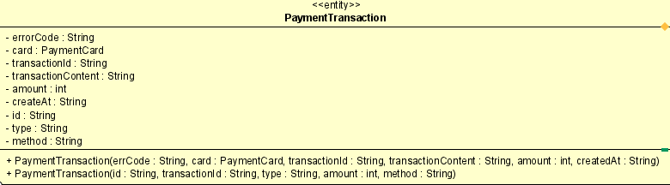

**Attribute**

|  |  |  |  |  |
| --- | --- | --- | --- | --- |
| # | Name | Data type | Default value | Description |
| 1 | errorCode | String | NULL | Error code |
| 2 | card | PaymentCard | NULL | Credit card |
| 3 | transactionId | String | NULL | Transaction id |
| 4 | transactionContent | String | NULL | Contents of transaction |
| 5 | amount | int | NULL | Transaction amount |
| 6 | createAt | String | NULL | Transaction create time |
| 7 | id | String | NULL | PaymentTransaction id |
| 8 | type | String | NULL | Transaction type |
| 9 | method | String | NULL | Transaction method |

**Operation**

None

Parameter:

None

Exception:

None

**Method**

None

**State**

None

#### Class “PaymentTransactionManager”

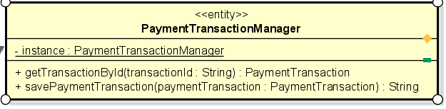

**Attribute**

|  |  |  |  |  |
| --- | --- | --- | --- | --- |
| # | Name | Data type | Default value | Description |
| 1 | instance | PaymentTransaction | NULL | Instance of transaction |

**Operation**

|  |  |  |  |
| --- | --- | --- | --- |
| # | Name | Return type | Desciption |
| 1 | getTransactionById | PaymentTransaction | Get transaction by Id |
| 2 | getCardByCardNumber | String | Save payment transaction |

Parameter:

TransactionId – transaction id

paymentTransaction

Exception:

None

**Method**

None

**State**

None

#### Class “Session”

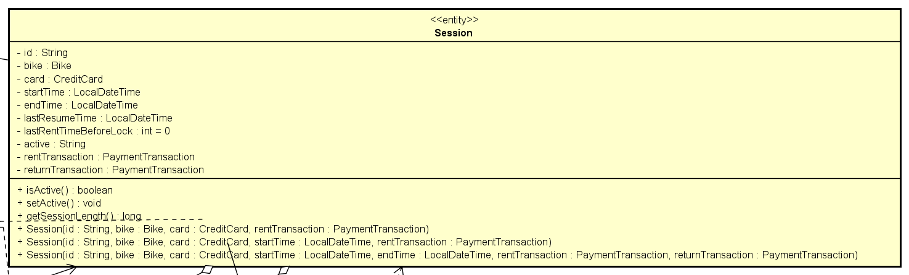

**Attribute**

|  |  |  |  |  |
| --- | --- | --- | --- | --- |
| # | Name | Data type | Default value | Description |
| 1 | id | String | NULL | Session id |
| 2 | bike | Bike | NULL | Bike in session |
| 3 | card | CreditCard | NULL | Card in session |
| 4 | startTime | LocalDateTime | NULL | Start time |
| 5 | endTime | LocalDateTime | NULL | End time |
| 6 | lastResumeTime | LocalDateTime | NULL | Last resume time |
| 7 | lastRentTimeBeforeLock | int | 0 | Last rent time before lock |
| 8 | active | String | NULL | Session active or not |
| 9 | rentTransaction | PaymentTransaction | NULL | Rent transaction |
| 10 | returnTransaction | PaymentTransaction | NULL | Return transaction |

**Operation**

|  |  |  |  |
| --- | --- | --- | --- |
| # | Name | Return type | Desciption |
| 1 | isActive | boolean | Session is active or not |
| 2 | setActive | void | Set session active |
| 3 | getSessionLength | long | Get session length |

Parameter:

None

Exception:

None

**Method**

None

**State**

None

#### Class “SessionManager”

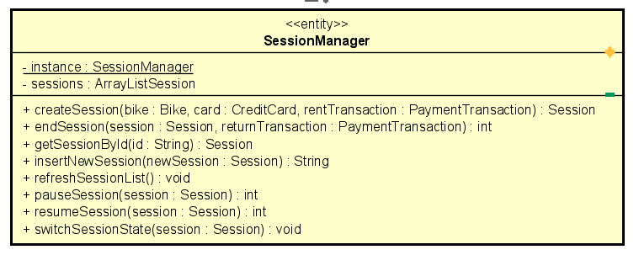

**Attribute**

|  |  |  |  |  |
| --- | --- | --- | --- | --- |
| # | Name | Data type | Default value | Description |
| 1 | instance | SessionManager | NULL | Session instance |
| 2 | sessions | ArrayList<Session> | NULL | Session list |

**Operation**

|  |  |  |  |
| --- | --- | --- | --- |
| # | Name | Return type | Desciption |
| 1 | createSession | Session | Create a session |
| 2 | endSession | int | Complete session |
| 3 | getSessionById | Session | Get session by id |
| 4 | insertNewSession | String | Insert new session to db |
| 5 | refreshSessionList | void | Refresh session list |
| 6 | pauseSession | int | Pause session |
| 7 | resumeSession | int | Resume session |

Parameter:

Bike

Card

PaymentTransaction

Session

newSession

Exception:

None

**Method**

None

**State**

None

#### Class “BikeScreenHandler”

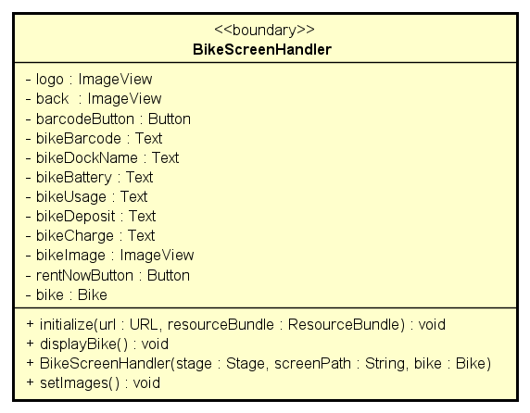

**Attribute**

|  |  |  |  |  |
| --- | --- | --- | --- | --- |
| # | Name | Data type | Default value | Description |
| 1 | logo | ImageView | NULL | Logo image fxml |
| 2 | back | imageView | NULL | Back image fxml |
| 3 | barcodeButton | Button | NULL | BarcodeButton fxml |
| 4 | bikeBarcode | Text | NULL | Bike barcode fxml |
| 5 | bikeDockName | Text | NULL | Dock name fxml |
| 6 | bikeBattery | Text | NULL | Bike battery fxml |
| 8 | bikeUsage | Text | NULL | Bike usage fxml |
| 9 | bikeDeposit | Text | NULL | Bike deposit fxml |
| 10 | bikeCharge | Text | NULL | Bike charge fxml |
| 11 | bikeImage | ImageView | NULL | Bike image |
| 12 | rentNowButton | Button | NULL | Rent button fxml |
| 13 | bike | Bike | NULL | bike |

**Operation**

|  |  |  |  |
| --- | --- | --- | --- |
| # | Name | Return type | Description |
| 1 | initialize | void | initialize |
| 2 | displayBike | void | Display bike info screen |
| 3 | setImages | void | Set bike image |

Parameter:

URL

ResourceBundle

Exception:

None

**Method**

None

**State**

None

#### Class “DockScreenHandler”

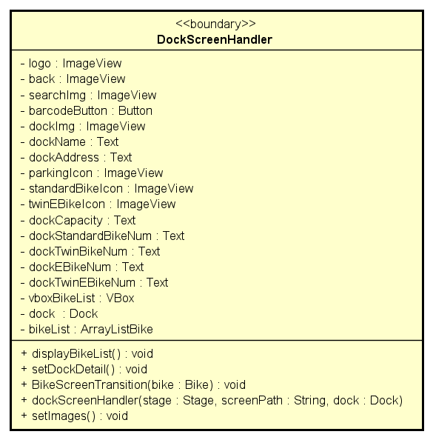

**Attribute**

|  |  |  |  |  |
| --- | --- | --- | --- | --- |
| # | Name | Data type | Default value | Description |
| 1 | logo | ImageView | NULL | Logo image fxml |
| 2 | back | imageView | NULL | Back image fxml |
| 3 | searchImg | imageView | NULL | Search image fxml |
| 4 | barcodeButton | Button | NULL | BarcodeButton fxml |
| 5 | dockName | Text | NULL | Dock name fxml |
| 6 | dockAddress | Text | NULL | Dock address fxml |
| 7 | dockImg | ImageView | NULL | Dock image fxml |
|  | parkingIcon | ImageView | NULL | Parking icon fxml |
|  | standardBikeIcon | ImageView | NULL | Standard bike icon fxml |
|  | twinEBikeIcon | ImageView | NULL | Twin bike icon fxml |
| 8 | dockStandardBikeNum | Text | NULL | Standard bike number fxml |
| 9 | dockTwinBikeNum | Text | NULL | Twin bike number fxml |
| 10 | dockEBikeNum | Text | NULL | E-bike number fxml |
| 11 | dockTwinEBikeNum | Text | NULL | Twin e-bikenumber fxml |
| 12 | vboxBikeList | VBox | NULL | Bike list fxml |
| 13 | dock | Dock | NULL | dock |
| 14 | bikeList | ArrayList<Bike> | NULL | Bike list in dock |

**Operation**

|  |  |  |  |
| --- | --- | --- | --- |
| # | Name | Return type | Description |
| 1 | displayBikeList | void | Display bike list |
| 2 | setDockDetail | void | Set dock detail |
| 3 | BikeScreenTransition | void | Transition to bike screen |
| 4 | setImages | void | Set dock image |

Parameter:

bike

Exception:

None

**Method**

None

**State**

None

#### Class “BikeListItemHandler”

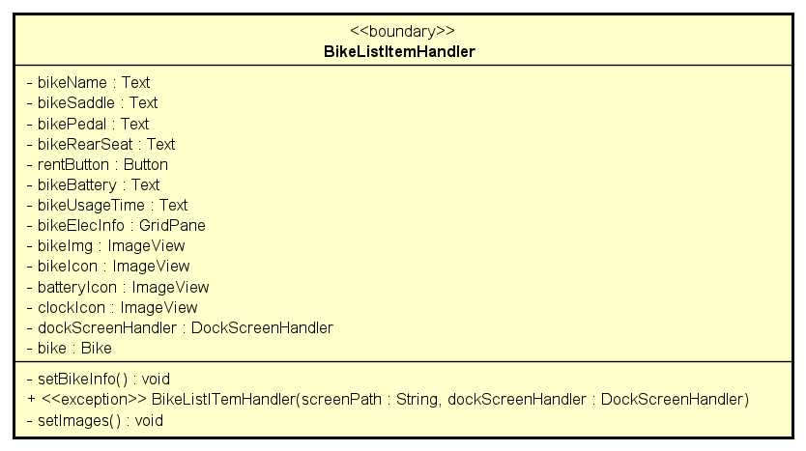

**Attribute**

|  |  |  |  |  |
| --- | --- | --- | --- | --- |
| # | Name | Data type | Default value | Description |
| 1 | bikeImg | ImageView | NULL | Bike image fxml |
| 2 | bikeIcon | imageView | NULL | Bike image fxml |
| 3 | rentButton | Button | NULL | Rent button fxml |
| 4 | bikeName | Text | NULL | Bike name fxml |
| 5 | bikeSaddle | Text | NULL | Bike saddle fxml |
| 6 | bikePedal | Text | NULL | Bike pedal fxml |
| 7 | bikeRearSeat | Text | NULL | Bike rear seat fxml |
| 8 | dockScreenHandler | DockScreenHandler | NULL | object |
| 9 | bike | Bike | NULL | object |

**Operation**

|  |  |  |  |
| --- | --- | --- | --- |
| # | Name | Return type | Description |
| 1 | setBikeInfo | void | Set bike info |
| 2 | setImages | void | Set bike imgae in list |

Parameter:

none

Exception:

IOException

**Method**

None

**State**

None

#### Class “BarcodePopup”

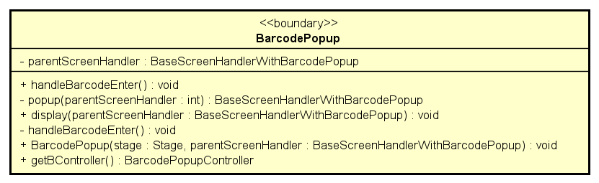

**Attribute**

|  |  |  |  |  |
| --- | --- | --- | --- | --- |
| # | Name | Data type | Default value | Description |
| 1 | parentScreenHandler | BaseScreenHandlerWithBarcodePopup | NULL | Parent screen |

**Operation**

|  |  |  |  |
| --- | --- | --- | --- |
| # | Name | Return type | Description |
| 1 | handleBarcodeEnter | void | Handle action “enter barcode” |
| 2 | popup | BaseScreenHandlerWithBarcodePopup | Popup |
| 3 | display | void | Display popup |
| 4 | handleBarcodeEnter | void | Button enter handler |
| 5 | getBController | BarcodePopupController | Get barcode |

Parameter:

parentScreenHandler

stage

Exception:

None

**Method**

None

**State**

None

#### Class “DockListItemHandler”

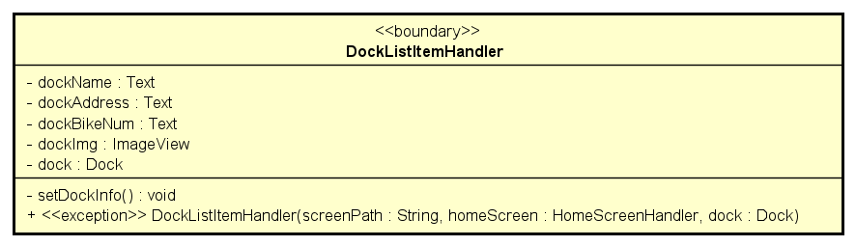

**Attribute**

|  |  |  |  |  |
| --- | --- | --- | --- | --- |
| # | Name | Data type | Default value | Description |
| 1 | dockName | Text | NULL | Dock name |
| 2 | dockAddress | Text | NULL | Dock address |
| 3 | dockBikeNum | Text | NULL | Number of bikes in dock |
| 4 | dockImg | ImageView | NULL | Dock image |
| 5 | dock | Dock | NULL | dock |

**Operation**

|  |  |  |  |
| --- | --- | --- | --- |
| # | Name | Return type | Description |
| 1 | setDockInfo | void | Set dock info |

Parameter:

none

Exception:

None

**Method**

None

**State**

None

#### Class “HomeScreenHandler”

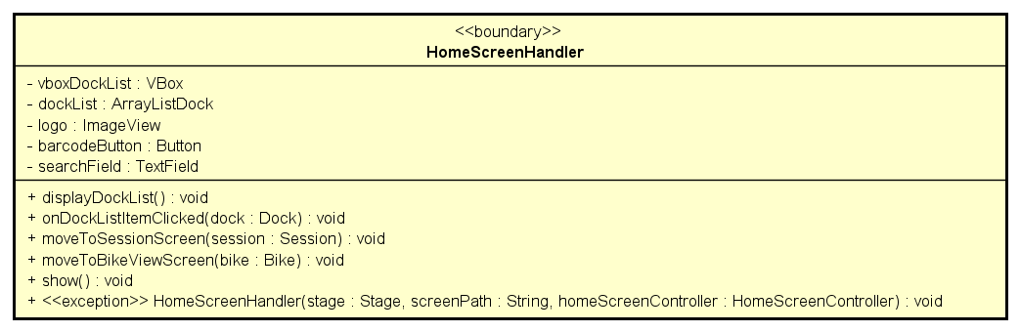

**Attribute**

|  |  |  |  |  |
| --- | --- | --- | --- | --- |
| # | Name | Data type | Default value | Description |
| 1 | vboxDockList | VBox | NULL | Vbox fxml |
| 2 | dockList | ArrayListDock | NULL | Dock list |
| 3 | logo | ImageView | NULL | Logo fxml |
| 4 | barcodeButton | Button | NULL | Barcode button fxml |
| 5 | searchField | TextField | NULL | Search field fxml |

**Operation**

|  |  |  |  |
| --- | --- | --- | --- |
| # | Name | Return type | Description |
| 1 | displayDockList | void | Display dock list |
| 2 | onDockListItemClicked | void | Dock list item clicked listener |
| 3 | moveToSessionScreen | void | Move to session screen |
| 4 | moveToBikeViewScreen | void | Move to bike view screen |
| 5 | show | void | Show screen |

Parameter:

dock

session

bike

Exception:

None

**Method**

None

**State**

None

#### Class “InvoiceScreenHandler”

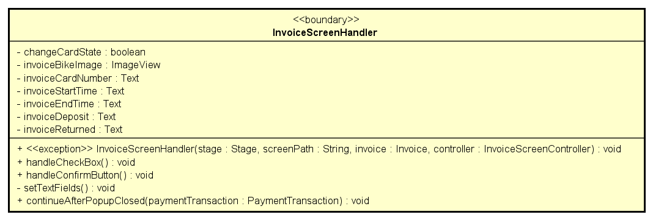

**Attribute**

|  |  |  |  |  |
| --- | --- | --- | --- | --- |
| # | Name | Data type | Default value | Description |
| 1 | changeCardState | boolean | NULL | Card state |
| 2 | invoiceBikeImage | ImageView | NULL | Bike image |
| 3 | invoiceCardNumber | Text | NULL | Invoice card number |
| 4 | invoiceStartTime | Text | NULL | Invoice start time |
| 5 | invoiceEndTime | Text | NULL | Invoice end time |
| 6 | invoiceDeposit | Text | NULL | Invoice deposit |
| 7 | invoiceReturned | Text | NULL | Invoice returned |

**Operation**

|  |  |  |  |
| --- | --- | --- | --- |
| # | Name | Return type | Description |
| 1 | handleCheckBox | void | Handle check box |
| 2 | handleConfirmButton | void | Handle confirm button |
| 3 | setTextFields | void | Set text fields |
| 4 | continueAfterPopupClosed | void | Continue program after popup close |

Parameter:

paymentTransaction

Exception:

None

**Method**

None

**State**

None

#### Class “PaymentConfirmationScreenHandler”

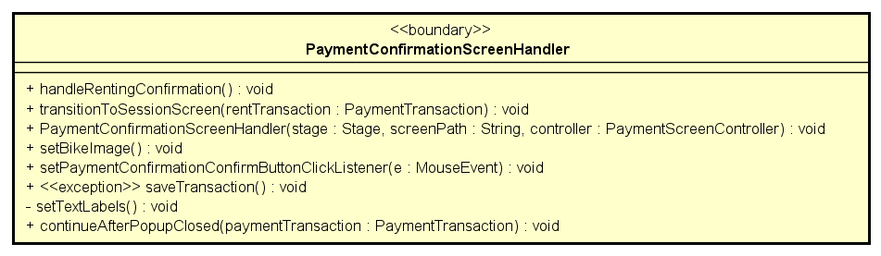

**Attribute**

None

**Operation**

|  |  |  |  |
| --- | --- | --- | --- |
| # | Name | Return type | Description |
| 1 | handleRentingConfirmation | void | Handle confirmation action |
| 2 | transitionToSessionScreen | void | Transition to session screen |
| 3 | setBikeImage | void | Set bike image |
| 4 | setPaymentConfirmationConfirmButtonClickListener | void | Payment Confirmation Confirm Button Click Listener |
| 5 | saveTransaction | void | Save transaction |
| 6 | setTextLabels | void | Set text |
| 7 | continueAfterPopupClosed | void | Continue program after popup close |

Parameter:

rentTransaction

paymentTransaction

mouseEvent

Exception:

IOException

**Method**

None

**State**

None

#### Class “PaymentScreenHandler”

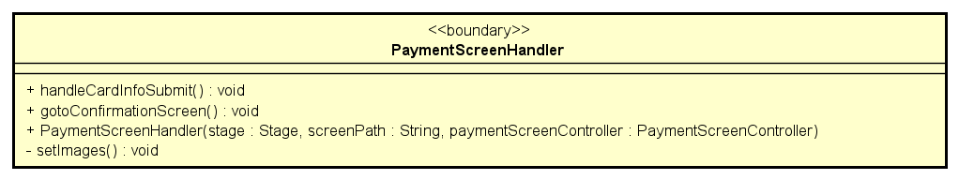

**Attribute**

|  |  |  |  |  |
| --- | --- | --- | --- | --- |
| # | Name | Data type | Default value | Description |

**Operation**

|  |  |  |  |
| --- | --- | --- | --- |
| # | Name | Return type | Description |
| 1 | handleCardInfoSubmit | void | Handle action submit card |
| 2 | gotoConfirmationScreen | void | Transition to confirmation screen |
| 3 | setImages | vodi | Set payment image |

Parameter:

None

Exception:

None

**Method**

None

**State**

None

#### Class “ReturningDockSelectionHandler”

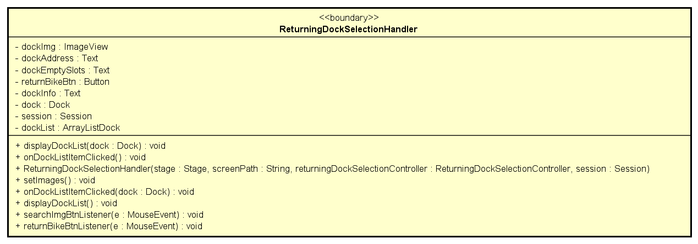

**Attribute**

|  |  |  |  |  |
| --- | --- | --- | --- | --- |
| # | Name | Data type | Default value | Description |
| 1 | dockName | Text | NULL | Dock name fxml |
| 2 | dockParkingSlot | Text | NULL | Dock parking slot fxml |
| 3 | dockImg | ImageView | NULL | Dock image fxml |
| 4 | dockInfo | Text | NULL | Dock information fxml |
| 5 | dockAdress | Text | NULL | Dock address fxml |
| 6 | dock | Dock | NULL | dock |
| 7 | session | Session | NULL | Session |
| 8 | dockList | ArrayListDock | NULL | Dock list |

**Operation**

|  |  |  |  |
| --- | --- | --- | --- |
| # | Name | Return type | Description |
| 1 | setDockInfo | void | Set dock info |
| 2 | onDockListItemClicked | void | Return dock clicked listener |
| 3 | setImages | void | Set return dock image |
| 4 | displayDockList | void | Display return dock list |
| 5 | searchImgBtnListener | void | Search image button listener |
| 6 | returnBikeBtnListener | void | Return bike button listener |

Parameter:

None

Exception:

None

**Method**

None

**State**

None

#### Class “ReturningDockListItemHandler”

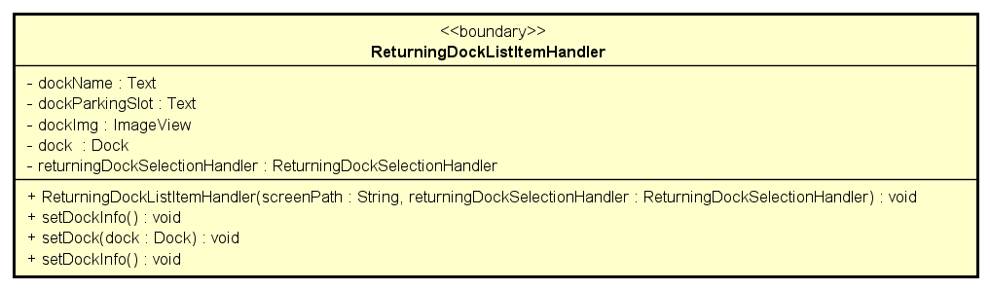

**Attribute**

|  |  |  |  |  |
| --- | --- | --- | --- | --- |
| # | Name | Data type | Default value | Description |
| 1 | dockName | Text | NULL | Dock name fxml |
| 2 | dockParkingSlot | Text | NULL | Dock address fxml |
| 3 | dockImg | ImageView | NULL | Dock image fxml |
| 4 | dock | Dock | NULL | dock |
| 5 | returningDockSelectionHandler | ReturningDockSelectionHandler | NULL | Returning Dock Selection Handler |

**Operation**

|  |  |  |  |
| --- | --- | --- | --- |
| # | Name | Return type | Description |
| 1 | setDockInfo | void | Display dock information |
| 2 | setDock | void | Display dock |

Parameter:

dock

Exception:

None

**Method**

None

**State**

None

#### Class “SessionScreenHandler”

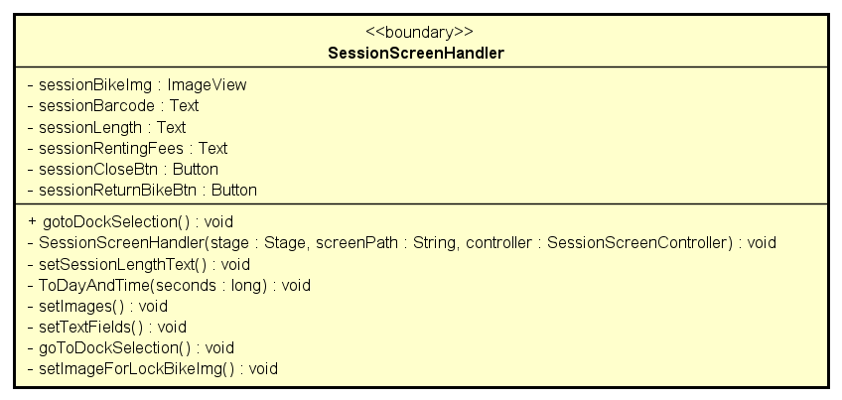

**Attribute**

|  |  |  |  |  |
| --- | --- | --- | --- | --- |
| # | Name | Data type | Default value | Description |
| 1 | sessionBikeImg | ImageView | NULL | Bike image fxml |
| 2 | sessionBarcode | Text | NULL | Session barcode fxml |
| 3 | sessionLength | Text | NULL | Session length fxml |
| 4 | sessionRentingFees | Text | NULL | Session renting fees fxml |
| 5 | sessionCloseBtn | Button | NULL | Button fxml |
| 6 | sessionReturnBikeBtn | Button | NULL | Button fxml |

**Operation**

|  |  |  |  |
| --- | --- | --- | --- |
| # | Name | Return type | Description |
| 1 | gotoDockSeletion | void | Transition to dock selection |
| 2 | setSessionLengthText | void | Set session’s length text |
| 3 | ToDayAndTime | void | Day and time conversion |
| 4 | setImages | void | Set image for session |
| 5 | setTextFields | void | Set text fields for session |
| 6 | goToDockSelection | void | Back to the dock selection |
| 7 | setImageForLockBikeImg | void | Set image for bike |

Parameter:

seconds

Exception:

None

**Method**

None

**State**

None

#### Class “SplashScreenHandler”

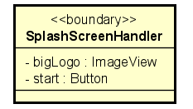

**Attribute**

|  |  |  |  |  |
| --- | --- | --- | --- | --- |
| # | Name | Data type | Default value | Description |
| 1 | bigLogo | ImageView | NULL | Logo image fxml |
| 2 | start | Button | NULL | Button fxml |

**Operation**

None

Parameter:

None

Exception:

None

**Method**

None

**State**

None

#### Class “NavBarHandler”

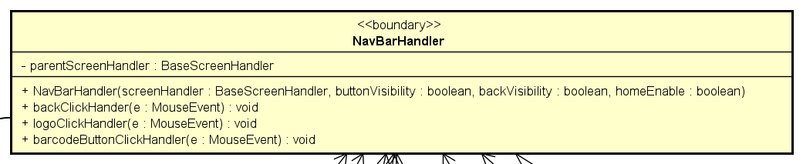

**Attribute**

|  |  |  |  |  |
| --- | --- | --- | --- | --- |
| # | Name | Data type | Default value | Description |
| 1 | parentScreenHandler | BaseScreenHandler | NULL | handler |

**Operation**

|  |  |  |  |
| --- | --- | --- | --- |
| # | Name | Return type | Description |
| 1 | backClickHandler | void | go to previous screen |
| 2 | logoClickHandler | void | go to home screen |
| 3 | barcodeButtonClickHandler | void | bring up barcode popup |

Parameter:

e – mouse event

Exception:

None

**Method**

None

**State**

None

#### Class “BaseScreenHandlerWithTransactionPopup”

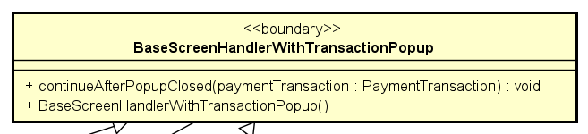

**Attribute**

None

**Operation**

|  |  |  |  |
| --- | --- | --- | --- |
| # | Name | Return type | Description |
| 1 | continueAfterPopupClosed | void | show then closed popup of payment result |

Parameter:

paymentTransaction – transaction to be shown result

Exception:

None

**Method**

None

**State**

None

#### Class “PaymentResultPopup”

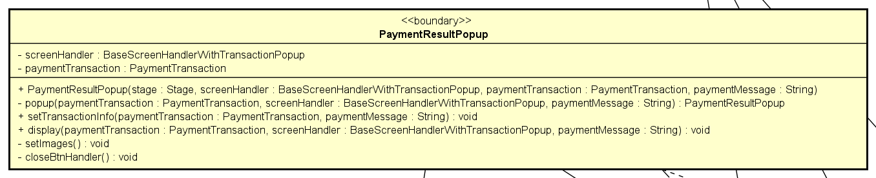

**Attribute**

|  |  |  |  |  |
| --- | --- | --- | --- | --- |
| # | Name | Data type | Default value | Description |
| 1 | screenHandler | BaseScreenHandlerWithTransactionPopup | new | handler |
| 2 | paymentTransaction | PaymentTransaction | NULL | transaction to be shown |

**Operation**

|  |  |  |  |
| --- | --- | --- | --- |
| # | Name | Return type | Description |
| 1 | setTransactionInfo | void | Display result |
| 2 | display | void | Render result |
| 3 | setImage | void | Set image for screen |
| 4 | closeBtnHandler | void | Close the popup and move to next screen |
| 5 | popup | PaymentResultPopup | Create then return popup |

Parameter:

screenHandler

paymentTransaction

paymentMessage

Exception:

None

**Method**

None

**State**

None

#### Class “FXMLScreenHandler”

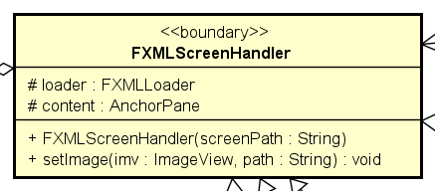

**Attribute**

|  |  |  |  |  |
| --- | --- | --- | --- | --- |
| # | Name | Data type | Default value | Description |
| 1 | loader | FXMLLoader | new |  |
| 2 | content | AnchorPane | NULL | main app anchor |

**Operation**

|  |  |  |  |
| --- | --- | --- | --- |
| # | Name | Return type | Description |
| 1 | setImage | void | set image for screen |

Parameter:

imv – image holder to be set

path – path to image

Exception:

None

**Method**

None

**State**

None

#### Class “BaseScreenHandler”

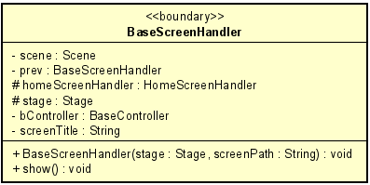

**Attribute**

|  |  |  |  |  |
| --- | --- | --- | --- | --- |
| # | Name | Data type | Default value | Description |
| 1 | scene | Scene | NULL | Scene to render |
| 2 | prev | BaseScreenHandler | NULL | Previous screen |
| 3 | homeScreenHandler | HomeScreenHandler | NULL | Home screen |
| 4 | stage | Stage | NULL | JavaFx stage |
| 5 | bController | BaseController | NULL | Controller for this screen |
| 6 | screenTitle | String | NULL | Title of this screen |

**Operation**

|  |  |  |  |
| --- | --- | --- | --- |
| # | Name | Return type | Description |
| 1 | show | void | Render the screen |

Parameter:

Exception:

None

**Method**

None

**State**

None

# Design Considerations

## Goals and Guidelines

Goals:

* The database design is focused on speed over optimal storage. As the non-functional requirements of the software demands for fast responsiveness and the EBR software is only used in the Eco park area; hence, the amount of data is not too large.

Guidelines:

* The naming convention will follow the Java naming convention.

## Architectural Strategies

* Design architecture: MVC – the reason has been stated above.
* Design principles: the design will follow the SOLID principles. These principles set has long history and, via practical usages, proved as effective.
* Database design: the software will use PostgreSQL as the DBMS.
* Framework to be used to develop the software will be JavaFX.

## Coupling and Cohesion

* Coupling:
  + There are no coupling issues at Content, Common and Control level.
  + Most of our classes and packages are at Data Coupling level, which is already a good design.
  + There some parts of design are at Stamp Coupling level such as in calculate renting fee as we pass the whole instance of Session into the method, but as we use the bike instance in the session and multiple other fields, this coupling is acceptable, a nice trade-off for the breeze of use. This holds true for other Stamp Coupling issues as well.
* Cohesion:
  + There is no component with Cohesion issues at Coincidental, Temporal, Procedural and Communicational level.
  + There’s an exception in utility class Utils: it contains method for both security methods (hash) and formatting methods (time, date, …). However, all those methods are static and this class acts only as helper/utility.

## Design Principles

* Single Responsibility Principle

Each of our designed classes follows this principle. Only exception is the Utils class as it contains method for both security and formatting. However, as explained in cohesion section, all these methods are global, so split it into 2 utility classes doesn’t affect much.

* Open / Closed Principle

For additional requirement of extending multiple renting fees formulas, we already using Strategy Pattern to solve the problem. And for others classes, the design also has many parent classes to use for generalization (e.g., StandardBike and StandardElecticalBike for adding new kind of bike, PaymentCard for adding new payment method, …)

* Liskov Substitution Principle

Yes, our design does follow the Liskov Substitution Principle. All the parent class can be substituted by its children classes. Our design has a clear and logical inheritance hierarchy.

* Interface Segregation Principle

The interbank system interface has already designed very simply and contains only 2 methods that needed for pay and refund.

* Dependency Inversion Principle

The higher-level modules do not depend on lower-level modules. All subsystem has their own interface for other to use. For the additional requirement, to add more Card type, we only need to make it extends the PaymentCard class.

## Design Patterns

* Singleton:
  + All manager model classes are designed using Singleton Pattern as these classes are used to provide and manipulate lots of share data throughout the software.
  + For example, the DockManager classes will store all queried docks for displaying, reading data. These manager classes should have only 1 instance as some are expensive and has no functional use to create extra instance.
* Strategy:
  + This pattern is used to solve the violation of Open/Closed Principle. Since, this pattern helps the design easy to scaleup when adding new variations of a method.
  + For example of implementation, the design uses this pattern in renting fee calculation by making a parent abstract class RentingFeeCalculator then let others type of Calculator extends it.
* Façade:
  + This pattern is used to reduce complexity of API of a service or interface of a subsystem.
  + The current design applies this pattern on the interbank subsystem, to make it interface simple and compact.